

< FICBANK>
< Internal Network and Web Applications>

Penetration Testing Plan & Report
Version 4.0
Feb 2025
Format to document:
- Table of Contents on its own page
- Document Revision on its own page (as you add information, be sure to align back to the top of page)
- Body of Document (as you add information, be sure to align back to the top of page)
- appendices on their own pages (as you add information, be sure to align back to the top of page)
- Delete all instructions from the final version of this document
- Names are fictious, as well as PII elements such as addresses, etc.
- Populate the information requested such as <client name> <system name>, etc., that is highlighted in blue. Delete the color but not the text in the final version of this report.
Table of Contents
1. Executive Summary 4
2. Rules of Engagement 4
2.1. Introduction 4
2.1.1. Penetration Testing 5
2.1.2. Vulnerability Testing 5
2.1.3. Post-Testing Actions 5
3. Penetration Testing Methodologies 6
3.1. Phase 1: Reconnaissance and Enumeration 6
3.1.1. Publicly Available Information 6
3.1.2. Service Banner and Fingerprinting Information 7
3.1.3. Live Hosts 7
3.1.4. Traceroute 7
3.1.5. Nmap 7
3.2. Phase 2: Vulnerability Discovery 8
3.2.1. Live Hosts 8
3.2.2. Open Ports and Services 8
3.2.3. Nikto, Dirb, and WPScan 9
3.2.4. OpenVAS 9
3.3. Phase 3: Exploitation 9
3.3.1. Findings 10
3.4. Phase 4: Recommendations 10
4. Appendices of Evidence 11
4.1. Appendix A – Reconnaissance and Enumeration Phase 12
4.2. Appendix B – Vulnerability Discovery Phase 25
4.3. Appendix C – Exploitation Phase 38
4.4. Appendix D – Post-Exploitation Cleanup Phase 38

Penetration Testing Plan & Report (PTR)
Prepared By
 | Organization that Prepared this Document
 | Organization Name | University of Maryland Global Campus Penetration Testing Team
 | Street Address | 3501 University Blvd East
 | Suite/Room/Building
 | City, State, Zip | Adelphi, MD 20783

Prepared For
Organization that Prepared this Document
Organization Name
Street Address
Suite/Room/Building
City, State, Zip

Document Revision History
Version | Date | Pages | Description | Author
4.0 | 02/19/2025 | All | First draft creation | Aryana Mahdavi

Executive Summary
FICBANK offers a software as a service (SaaS) cloud service offering to the federal agency Department of University and has retained University of Maryland Global Campus Penetration Testing Team (UMGC PTT) to perform a penetration test (pen test) of Internal Network and Web Applications in accordance with all federal laws, regulations, and statues to include the National Institute of Standards in Technology (NIST). The Internal Network and Web Applications pen test is a representation of the security posture as of the end of date of penetration testing (pen testing), prior to any mitigation. This Penetration Test Report (PTR) provides the results of the activities performed and serves as a permanent record of the pen testing activities. The testing includes automated and manual activities using the pen testing tool Kali Linux, native operating system tool command prompt, and manual testing.

Rules of Engagement
During the pen test, the UMGC PTT will attempt to identify exploitable weaknesses of FICBANK system Internal Network and Web Applications, including but not limited to application flaws, improper configurations, and end-user behavior to evaluate the company’s security policy compliance, employee’s security awareness, and the organization’s ability to identify and respond to security incidents. Findings will be validated, documented, and given an appropriate impact rating when can be found in the Table under the Findings section of this report. The primary goal of this penetration test includes:
- Improve Security Posture: Provide actionable recommendations to strengthen defenses and reduce risks based on identified vulnerabilities.
- Assess Incident Response Capabilities: Evaluate how well FICBANK can detect and respond to simulated attacks, including its logging and monitoring capabilities.
- Validate Security Controls: Test the effectiveness of existing security measures and configurations to ensure they are working as intended.
- Identify and Exploit Vulnerabilities: Detect weaknesses in FICBANK's internal network and web applications that attackers could exploit.
- Ensure Compliance: Confirm adherence to industry standards, best practices, and regulatory requirements, such as NIST and ISO 27001.

Introduction
Under the Federal Information Security Management Act of 2002 (FISMA), the Office of Management and Budget (OMB) directed NIST to develop specific guidance for federal agencies and those providing services on behalf of federal agencies, to test and assess the security of their information systems. Network vulnerability assessment and penetration testing of information systems are for all information systems within the federal government. This testing is in accordance with the guidance found in the NIST Special Publication (SP) 800-115, Technical Guide to Information Security Testing and Assessment, which provides specific guidance for conducting these tests and assessments, including guidance for developing Rules of Engagement (ROE).
This ROE establishes guidelines for the UMGC PTT to conduct vulnerability assessments and penetration testing of system and network components throughout the FICBANK enterprise. Within this document and unless otherwise specified, the terms “test” and “testing” refer to both network vulnerability assessment and penetration testing used to evaluate FICBANK systems. This document also serves to protect both parties by authorizing UMGC staff’s penetration testing teams to perform vulnerability assessments and penetration tests against FICBANK assets.

Penetration Testing
Penetration testing is security testing in which assessors mimic real-world attacks to identify methods for circumventing the security features of an application, system, or network. It often involves launching real attacks on real systems and data, using tools and techniques commonly employed by attackers. Most penetration tests involve looking for combinations of vulnerabilities on one or more systems that can be used to gain more access than could be achieved through a single vulnerability. Penetration testing can also be useful for determining:
  - How well the system tolerates real-world attack patterns
  - The likely level of sophistication an attacker needs to successfully compromise the system
  - Additional countermeasures that could mitigate threats against the system
  - The defenders’ ability to detect attacks and respond appropriately
  - Assess the security posture of the target system
  - Identify gaps in the implementation of defense in depth security
  - Evaluate device configuration

Vulnerability Testing
A network vulnerability assessment is not the same as a penetration test. Vulnerability testing is typically automated systematic examination of an information system or product intended to accomplish these objectives:
  - Determine whether security controls are adequately designed and effectively implemented
  - Identify security deficiencies and determine the effectiveness of external perimeter and internal security controls
  - Provide a basis for evaluating the effectiveness of proposed or implemented security measures
  - Map the vulnerabilities with associated exploits
  - Post-implementation confirmation of changes made to the security baseline and other protective measures

Post-Testing Actions
Once testing is complete, the UMGC PTT will work closely with the target system personnel to identify corrective actions needed to remediate vulnerabilities and suggest methods for improvement. Per NIST 800-53 Revision 5, System and Information Integrity (SI) control family, SI-2 Flaw Remediation, system flaws must be identified, reported, and corrected within organization-defined timelines. Although normal operational timelines are correcting flaws within 30 days, the UMGC PTT must correct any system flaws as a result of these testing within 10 days following the conclusion of all testing.

Penetration Testing Methodologies

Phase 1: Reconnaissance and Enumeration

Publicly Available Information

Finding 1: The search returned pages about UMGC's online programs, global locations, and resources like CareerQuest and MARS Portal. Specific topics include career bootcamps, library resources, and administrative information.

Finding 2: The inurl:DVWA search revealed GitHub repositories containing DVWA’s source code and documentation. These repositories detailed vulnerabilities such as SQL injection, which could provide insights for further testing.
Finding 3: The search using site:umgc.edu filetype:pdf revealed several publicly available PDF documents from UMGC.
These include Documents on Alumni Activities: Advisory board meeting details and alumni benefits information. UMGC Cares Campaign FAQs: Fundraising details that could reveal organizational priorities or operations. Course Catalogs and Academic Programs: Information about past and current course offerings, which might indirectly highlight IT practices or legacy systems.
These documents provide publicly accessible information that could be used for profiling the organization’s activities and infrastructure.
Finding 4: The intext: cybersecurity search gave some interesting results about UMGC’s cybersecurity programs. It highlighted their bachelor’s and master’s degrees in cybersecurity, as well as certifications like Security+. There were also mentions of their cybersecurity bootcamps, which offer hands-on training and mentorship. Another cool find was UMGC’s Cyber Competition Team, which is apparently award-winning and gives students real-world experience. Overall, it shows UMGC’s strong focus on cybersecurity education and industry readiness.
Finding 5: PDFs detail local government cybersecurity challenges, program curricula, and cyber threat hunting certificates, offering insights into UMGC's priorities and potential legacy systems.

Service Banner and Fingerprinting Information
Service Banner and Fingerprinting Results
Dig | A Records: 151.101.195.10, 151.101.131.10, 151.101.67.10, 151.101.3.10. Query Time: 8ms. DNS Server: 10.205.1.15.
Nslookup or Whois | Resolved IPs: 151.101.67.10, 151.101.3.10, 151.101.131.10, 151.101.195.10. Server: 10.205.1.15.

Live Hosts
Ping Sweep Results
Host 1  10.13.246.8 | Live  Responded with latency of 0.0012s.
Host 2  10.13.246.9 | Live  Responded with latency of 0.0012s.

Traceroute
Traceroute Results
Host 1 10.13.246.8 | No hops identified. Likely due to blocked ICMP/UDP packets or firewall.
Host 2  10.13.246.9 | No hops identified. Likely due to blocked ICMP/UDP packets or firewall.

Nmap
Nmap Enumeration Results
Host 1  10.13.246.8 | For Host 1, it's online and responsive. Nmap picked up two open ports:  Port 80 (HTTP): This is running a Microsoft Azure Web App, but it shows an "Error 404" message saying "Site Not Found." Nothing really juicy here.  Port 443 (HTTPS): Same story here with HTTPS, also running on Microsoft Azure. The SSL certificate is issued by Microsoft Corporation, and it's valid until mid-2025. It covers a bunch of Azure-related domains, like *.azurewebsites.net and *.scm.azurewebsites.net.  OS detection didn’t give us much – no valid fingerprint was identified. The network distance is just 1 hop, so it’s super close.
Host 2  10.13.246.9 | For Host 2, it's also online and responsive. Here’s what we found:  Port 80 (HTTP): Just like Host 1, it’s showing a Microsoft Azure Web App with the same "Error 404" message.  Port 443 (HTTPS): Again, it's HTTPS with the same Azure SSL certificate as Host 1. The certificate details are identical—same issuer, same DNS names, and the same expiration date.  OS detection? Still nothing conclusive here either. And just like Host 1, it’s only 1 hop away.
…

Phase 2: Vulnerability Discovery

Live Hosts
Nmap Scan for Live Hosts Results
Host  Host  Host  Host  Host  Host  Host  Host  Host | 1 10.13.246.5 0.0016s  2 10.13.246.8 0.0016s  3 10.13.246.9 0.0016s  4 10.13.246.10 0.0015s  5 10.13.246.11 0.0016s  6 10.13.246.12 0.0019s  7 10.13.246.13 0.0019s  8 10.13.246.14 0.0018s  9 10.13.246.17 0.0069s

Open Ports and Services
Nmap Scan for Open Ports and Services Results
Host 1  Host 2  Host 3  Host 4  Host 5  Host 6  Host 7  Host 8  Host 9  Host 10  Host 11  Host 12 | 10.13.246.5 80, 443 HTTP, HTTPS  10.13.246.8 80, 443 HTTP, HTTPS  10.13.246.9 80, 443 HTTP, HTTPS  10.13.246.10 80, 443 HTTP, HTTPS  10.13.246.11 80, 443 HTTP, HTTPS  10.13.246.12 80, 443 HTTP, HTTPS  10.13.246.13 80, 443 HTTP, HTTPS  10.13.246.14 80, 443 HTTP, HTTPS  10.13.246.17 22 SSH

Nikto, Dirb, and WPScan
Nikto, Dirb, and WPScan Results
Nikto  10.13.246.12 | - X-Frame-Options header is missing (anti-clickjacking vulnerability).  - X-XSS-Protection header is not defined.  - X-Content-Type-Options header is missing (content-type rendering vulnerability).  - No CGI directories found.
Dirb 10.13.246.12 | - No directories or files found using the common wordlist.  - Total scanned words: 4612  - Results found: 0
WPScan 10.13.246.12 | - The remote website is reachable but does not appear to be running WordPress.  - No WordPress vulnerabilities were identified.

OpenVAS
OpeVAS Results
Target | Severity Level | Vulnerability Name
Host 1  10.11.130.36 | Medium (5.0)  Low (2.6) | SSL/TLS: Report Weak Cipher Suites  Weak MAC Algorithm(s) Supported (SSH)
Host 210.13.246.8 | None | No vulnerabilities detected

Phase 3: Exploitation

Findings
Task | Documented Findings
-Payloads and Exploits | Used exploit/unix/ftp/vsftpd_234_backdoor to exploit a known backdoor vulnerability in VSFTPD 2.3.4. This exploit sends a sequence of specific bytes to port 21, potentially opening a backdoor. However, the FTP service was found to be closed on the target system (nmap -p 21 [10.11.130.37] showed port 21 as closed). As a result, the exploit attempt failed.
-Social Engineering Toolkit | Successfully launched the Social-Engineer Toolkit (SET) on Kali Linux by running setoolkit. Navigated through the SET menu to Website Attack Vectors and selected Credential Harvester Attack Method. The tool cloned a fake login page for Google, hosted on Kali at http://10.11.130.36
-Phishing Attack Using Credential Harvester | Successfully captured credentials when tested from the Windows VM. The harvested credentials included the email cst630@gmail.com and password cst630-2024$1. The attack was logged and stored in the .set directory. The listener on port 80 successfully received HTTP GET and POST requests, confirming data interception.

Phase 4: Recommendations
No. | Your Findings | Remediation Recommendations
1 | Open Ports and Services: Nmap scan revealed multiple open ports, including 80 (HTTP), 443 (HTTPS), and 22 (SSH). These could be exploited if misconfigured or left exposed. | Implement firewall rules to restrict access to necessary ports only. Disable or secure unused ports to minimize attack surfaces. Use SSH key-based authentication instead of password-based logins.
2 | Vulnerabilities in Web Application Security Headers: The Nikto scan revealed missing X-Frame-Options, X-XSS-Protection, and X-Content-Type-Options headers, making the application susceptible to clickjacking and cross-site scripting (XSS) attacks. | Configure security headers in web server settings to prevent clickjacking and XSS. Use Content Security Policy (CSP) and ensure all headers are properly set.
3 | Successful Credential Harvesting Attack: The Social Engineering Toolkit (SET) was used to clone a fake login page, successfully capturing email and password credentials from the victim’s machine. | Conduct employee security awareness training on phishing and social engineering threats. Implement multi-factor authentication (MFA) to reduce risk even if credentials are stolen. Deploy email filtering solutions to detect and block phishing attempts.
Note: Additional details can be found in the Project 4 Lab— the Post-Exploitation Cleanup and Reporting.

Appendices of Evidence

Appendix A – Reconnaissance and Enumeration Phase
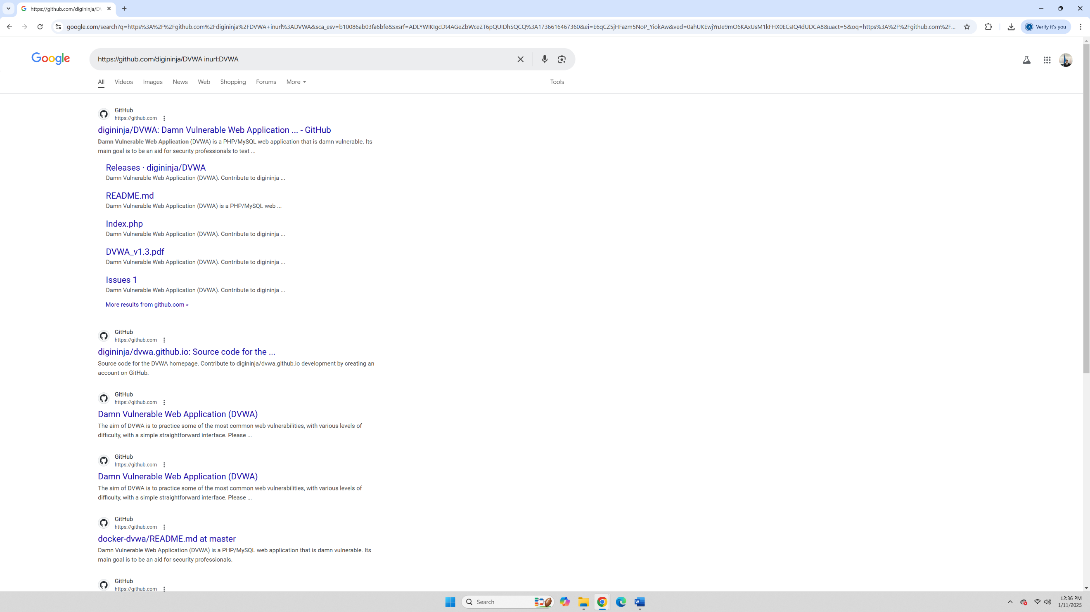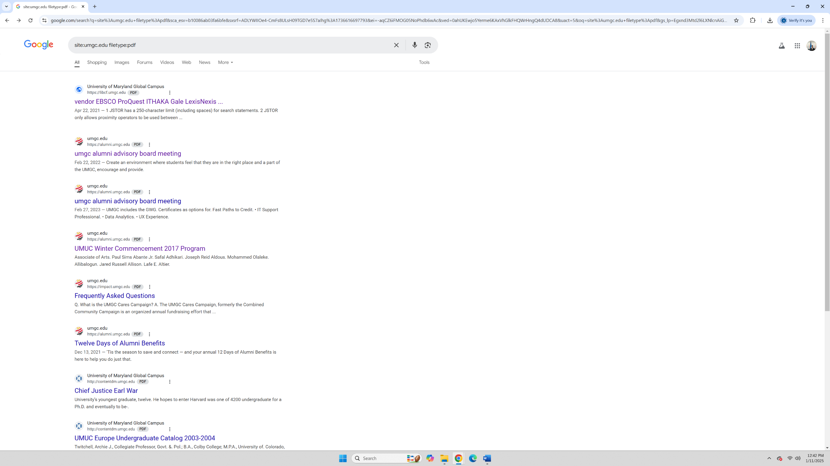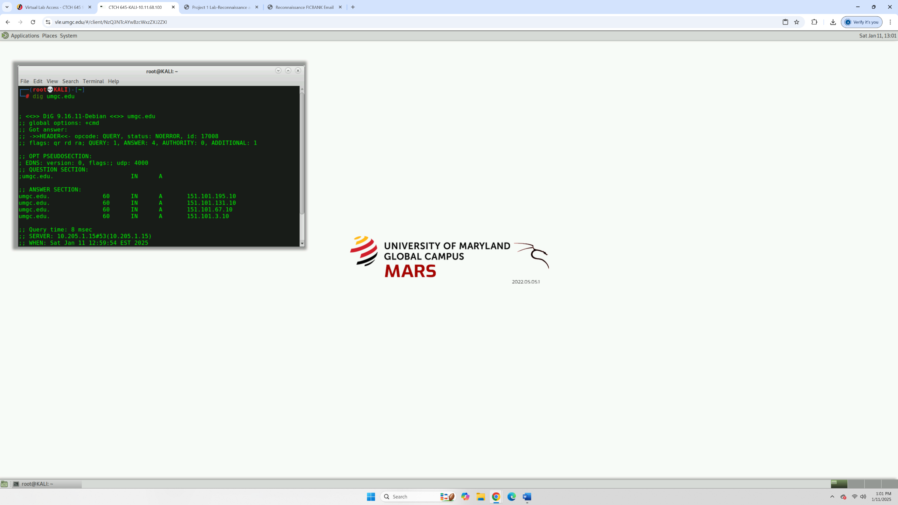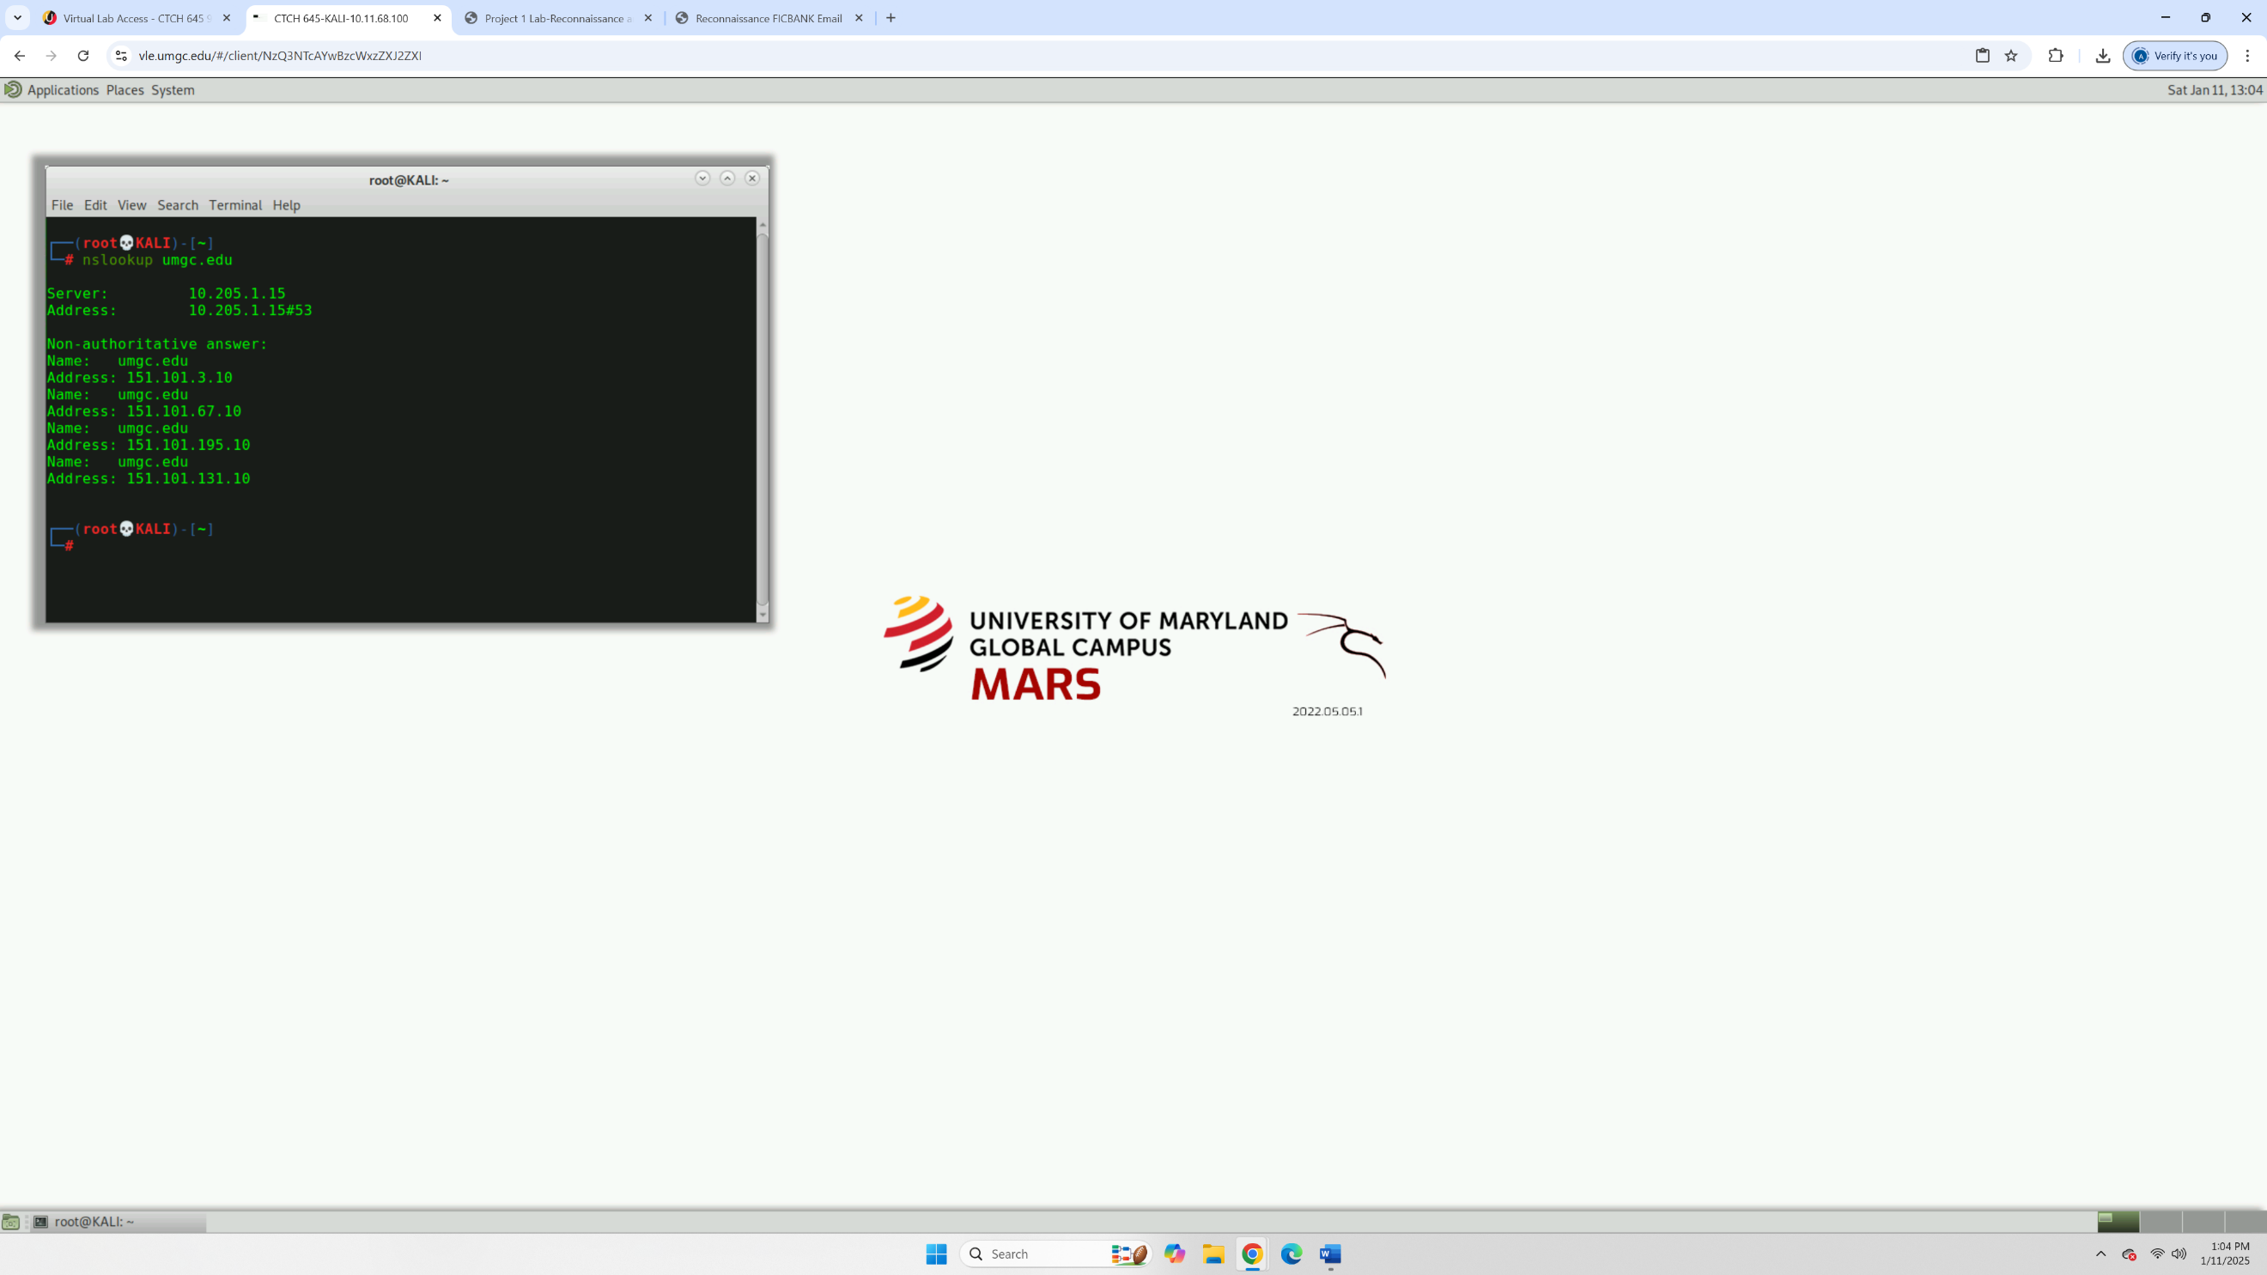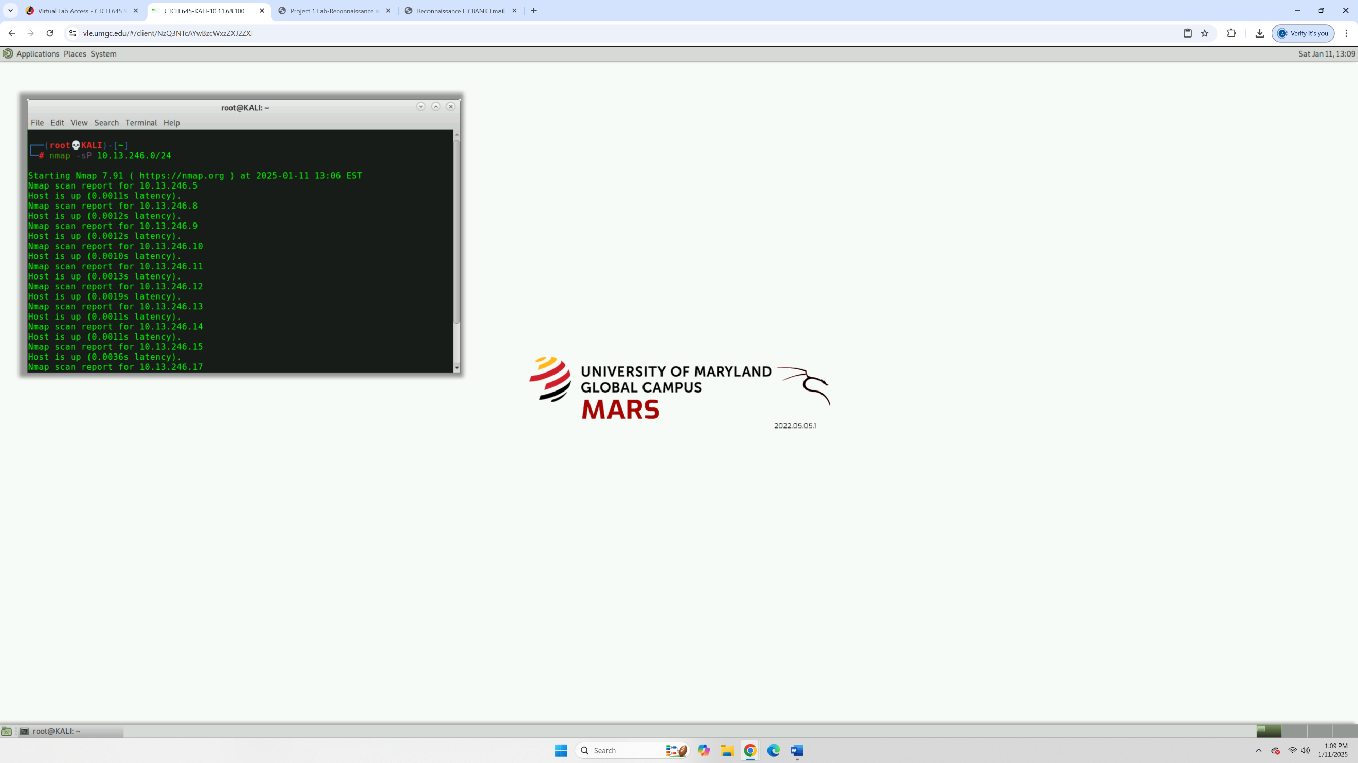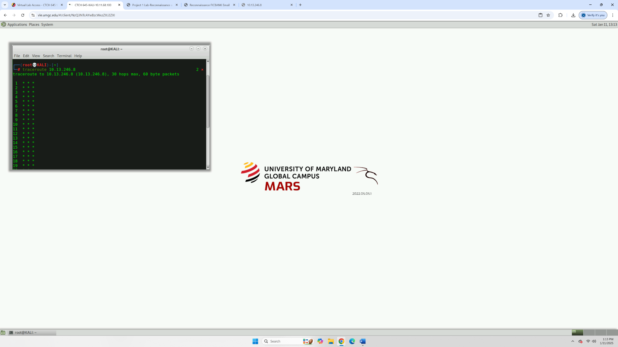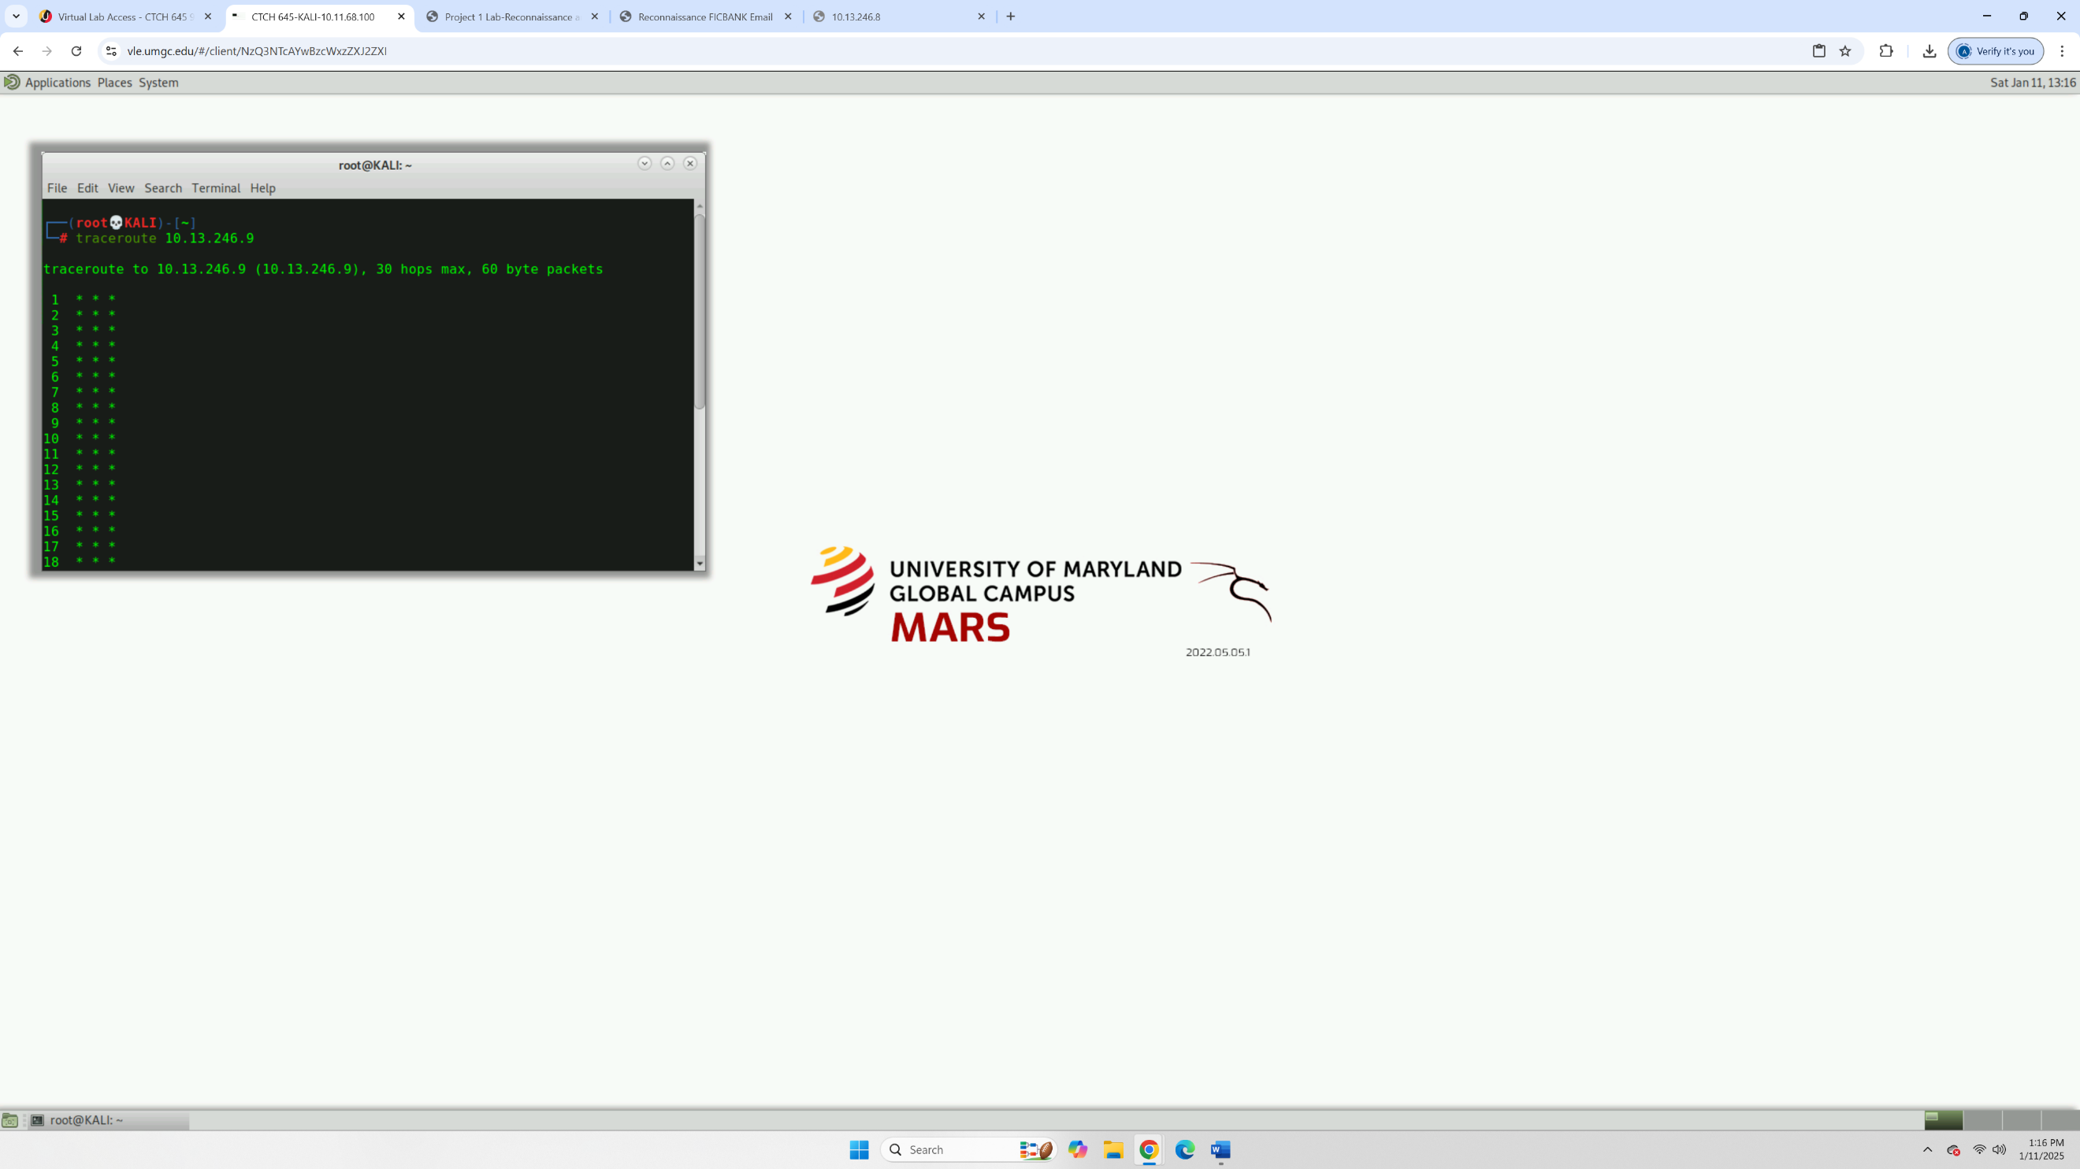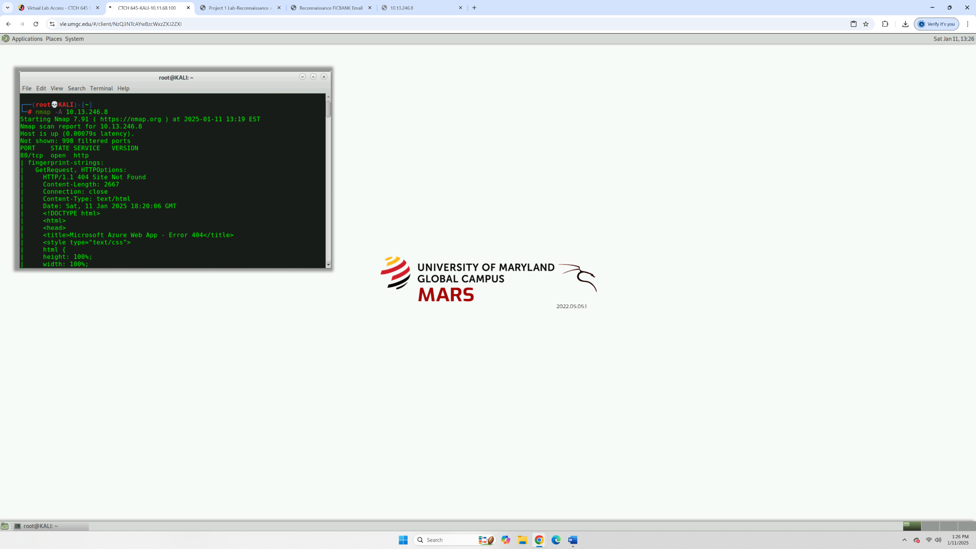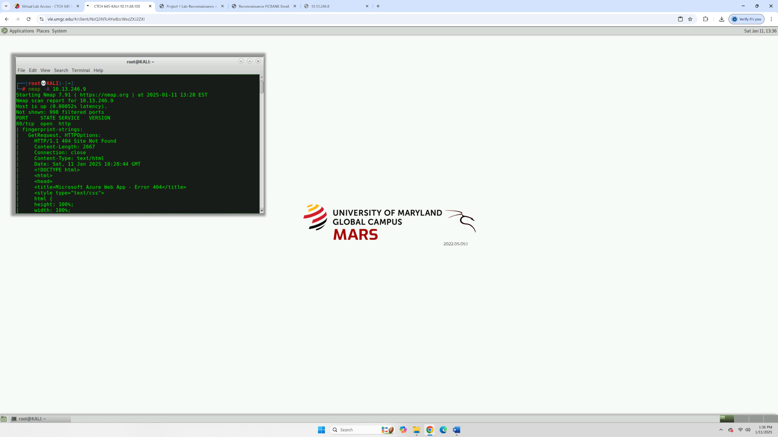

How might publicly accessible information support pen testing goals?
Publicly accessible information is like gold for pen testers. It helps you understand the target organization before even touching their systems. For example, finding technical details like IP addresses, server configurations, or employee information can highlight potential weaknesses. Even things like job postings can reveal technologies in use "We’re looking for a Windows admin for Active Directory". Essentially, this kind of intel gives you a roadmap to identify vulnerabilities without alerting the target.

How can search techniques be used by black hat and white hat hackers?
Search techniques are tools, and like any tool, it depends on who’s using them. A black hat hacker might use advanced Google searches (Google Dorking) to find sensitive information like exposed login pages or unprotected files. On the other hand, a white hat hacker uses the same techniques to help organizations uncover and secure these gaps before an attacker does. It's the same skillset, but the intent makes all the difference, white hats aim to fix, and black hats aim to exploit.
- What differences exist between active and passive reconnaissance?
The main difference lies in interaction. Passive reconnaissance is stealthy, you’re observing without touching the target. Think of it like watching someone through a window without them knowing. For example, checking public websites or social media is passive. Active reconnaissance, on the other hand, is more direct and noticeable. It's like knocking on someone’s door to see if they’re home. Tools like nmap scans and ping commands interact directly with the target system, which could alert them to your activity. Passive is quieter, but active gets you more detailed information.
- What are the benefits of scanning multiple hosts or a subnet versus individual hosts?
Scanning multiple hosts or a subnet gives you a broader picture of the network. It’s like shining a flashlight in a dark room instead of just focusing on one corner. You might discover:
Additional devices that could be entry points, misconfigured systems or exposed services that were overlooked, patterns or trends, like repeated vulnerabilities across multiple hosts.
On the flip side, individual host scans are useful when you need to dig deeper into a specific system after identifying it as a potential weak spot.
- Propose strategies to mitigate identified risks
Here are a few practical strategies to address risks:
Close Unnecessary Ports: If a service isn’t needed, shut it down to reduce attack surfaces.
Secure Configuration: For services like HTTP or HTTPS, enforce secure settings like SSL/TLS encryption and proper certificate management.
Regular Vulnerability Scans: Automate scans to catch new vulnerabilities as they emerge.
Use Firewalls and IDS: Restrict traffic to necessary ports and monitor for unusual activity.
Employee Training: People are often the weakest link, so educating them on phishing and secure practices can go a long way.
Patch Management: Keep software and systems updated to address known vulnerabilities.

Appendix B – Vulnerability Discovery Phase

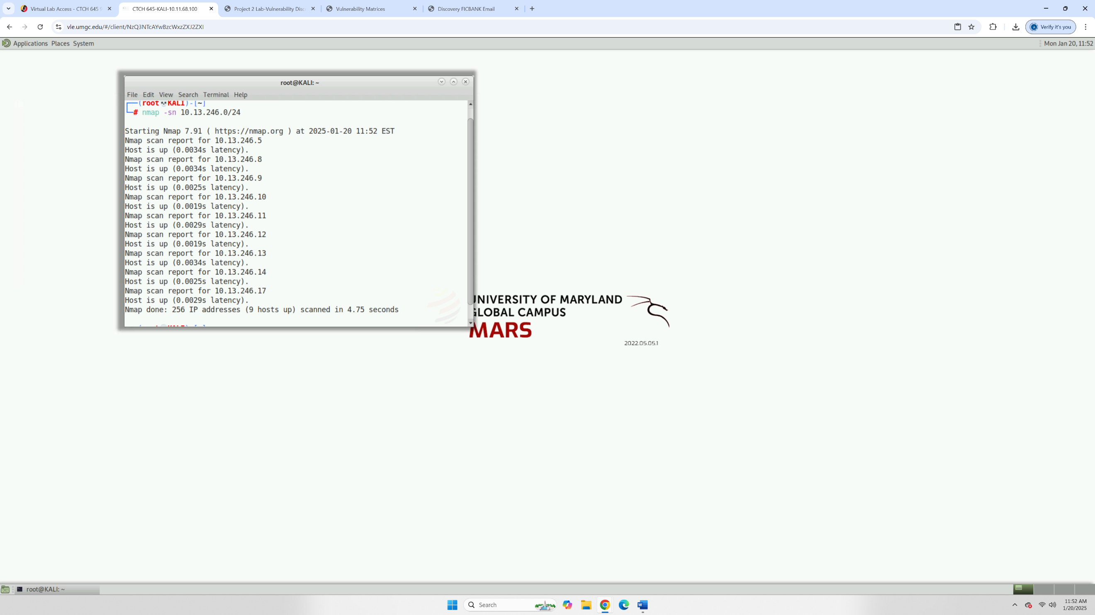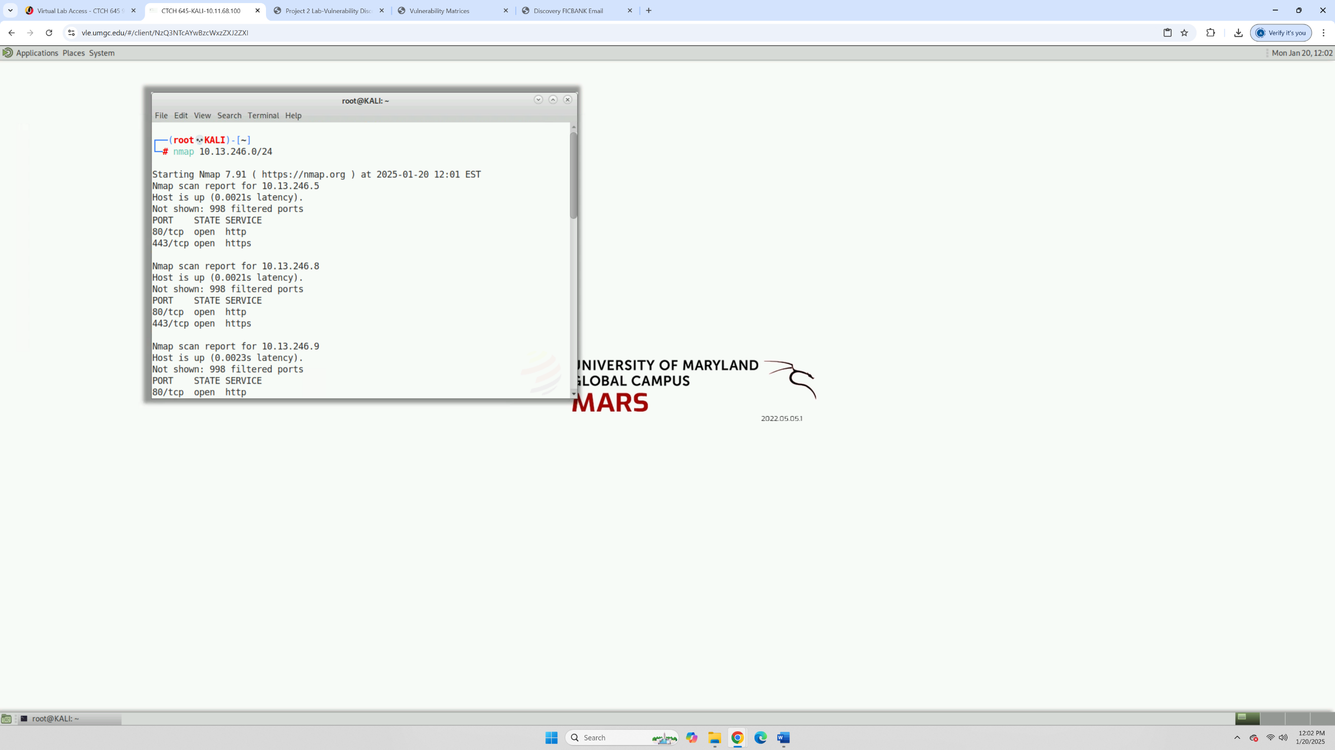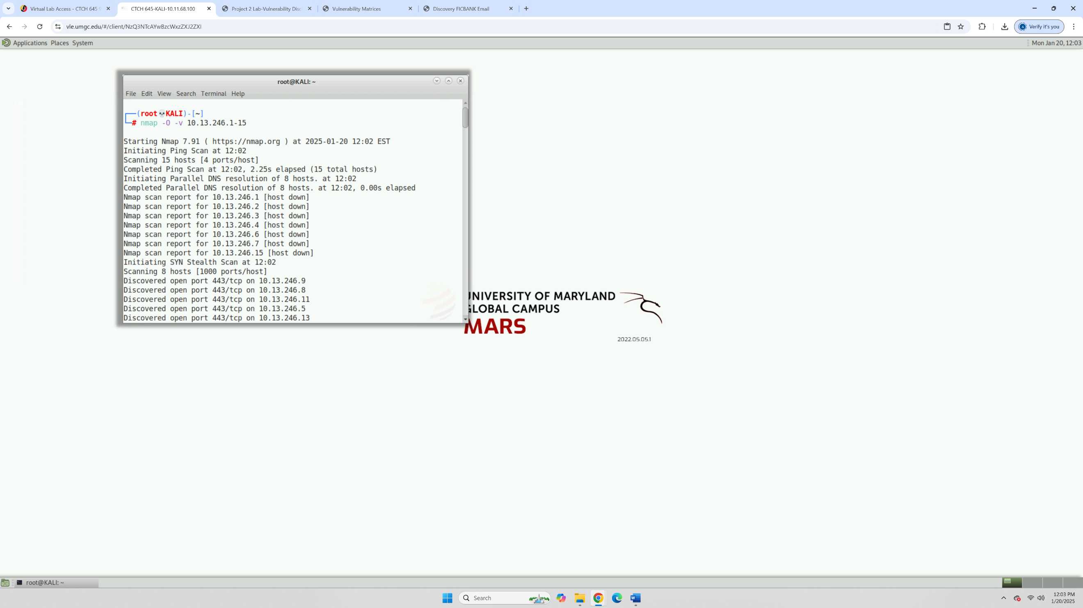
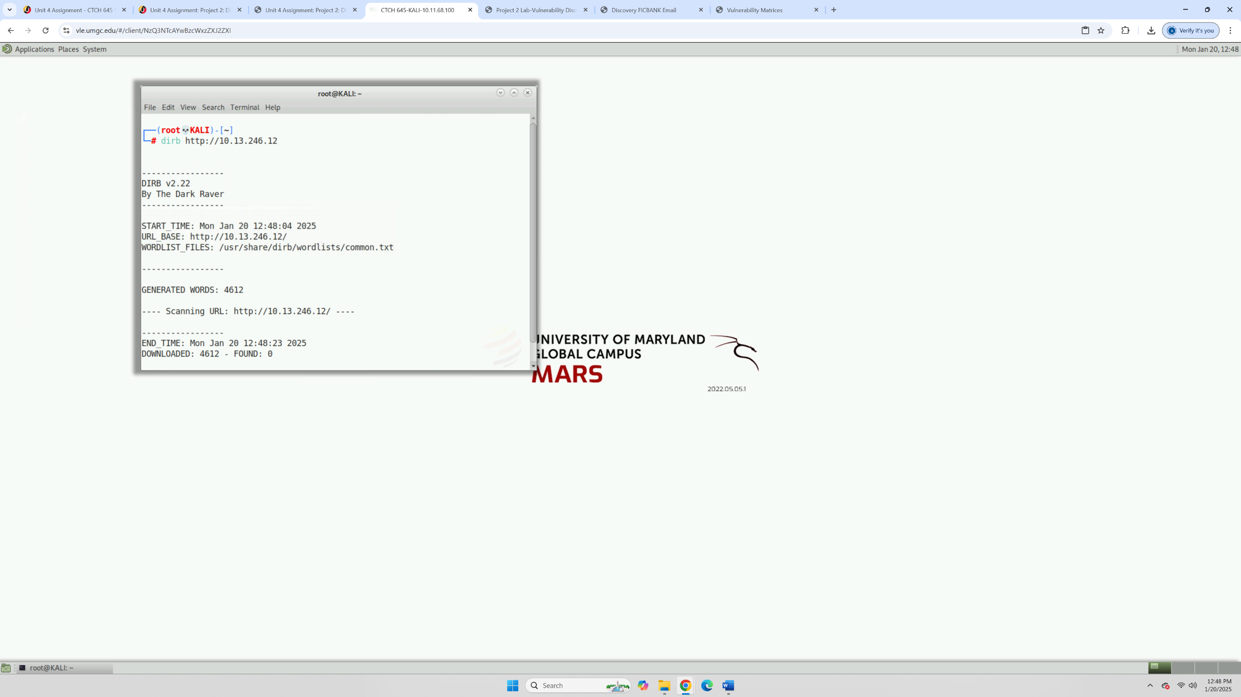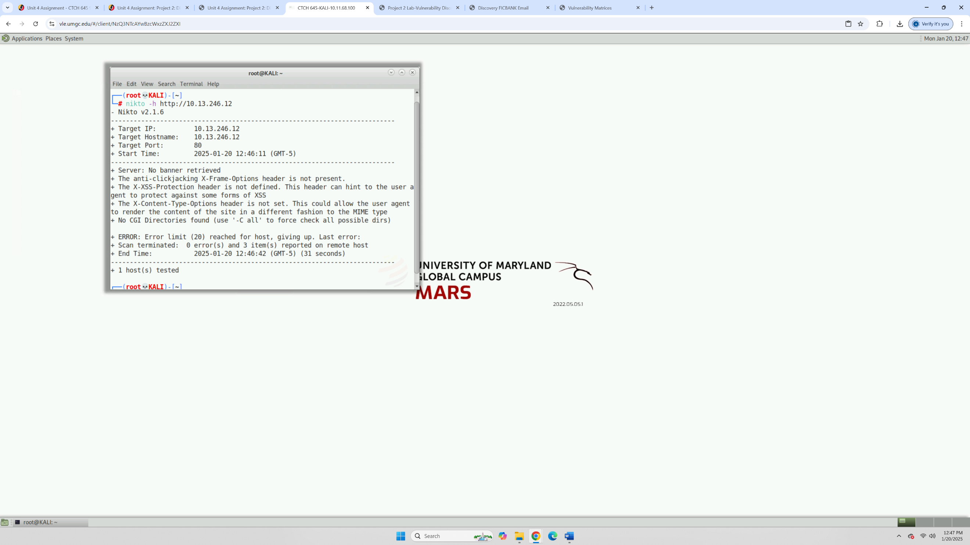
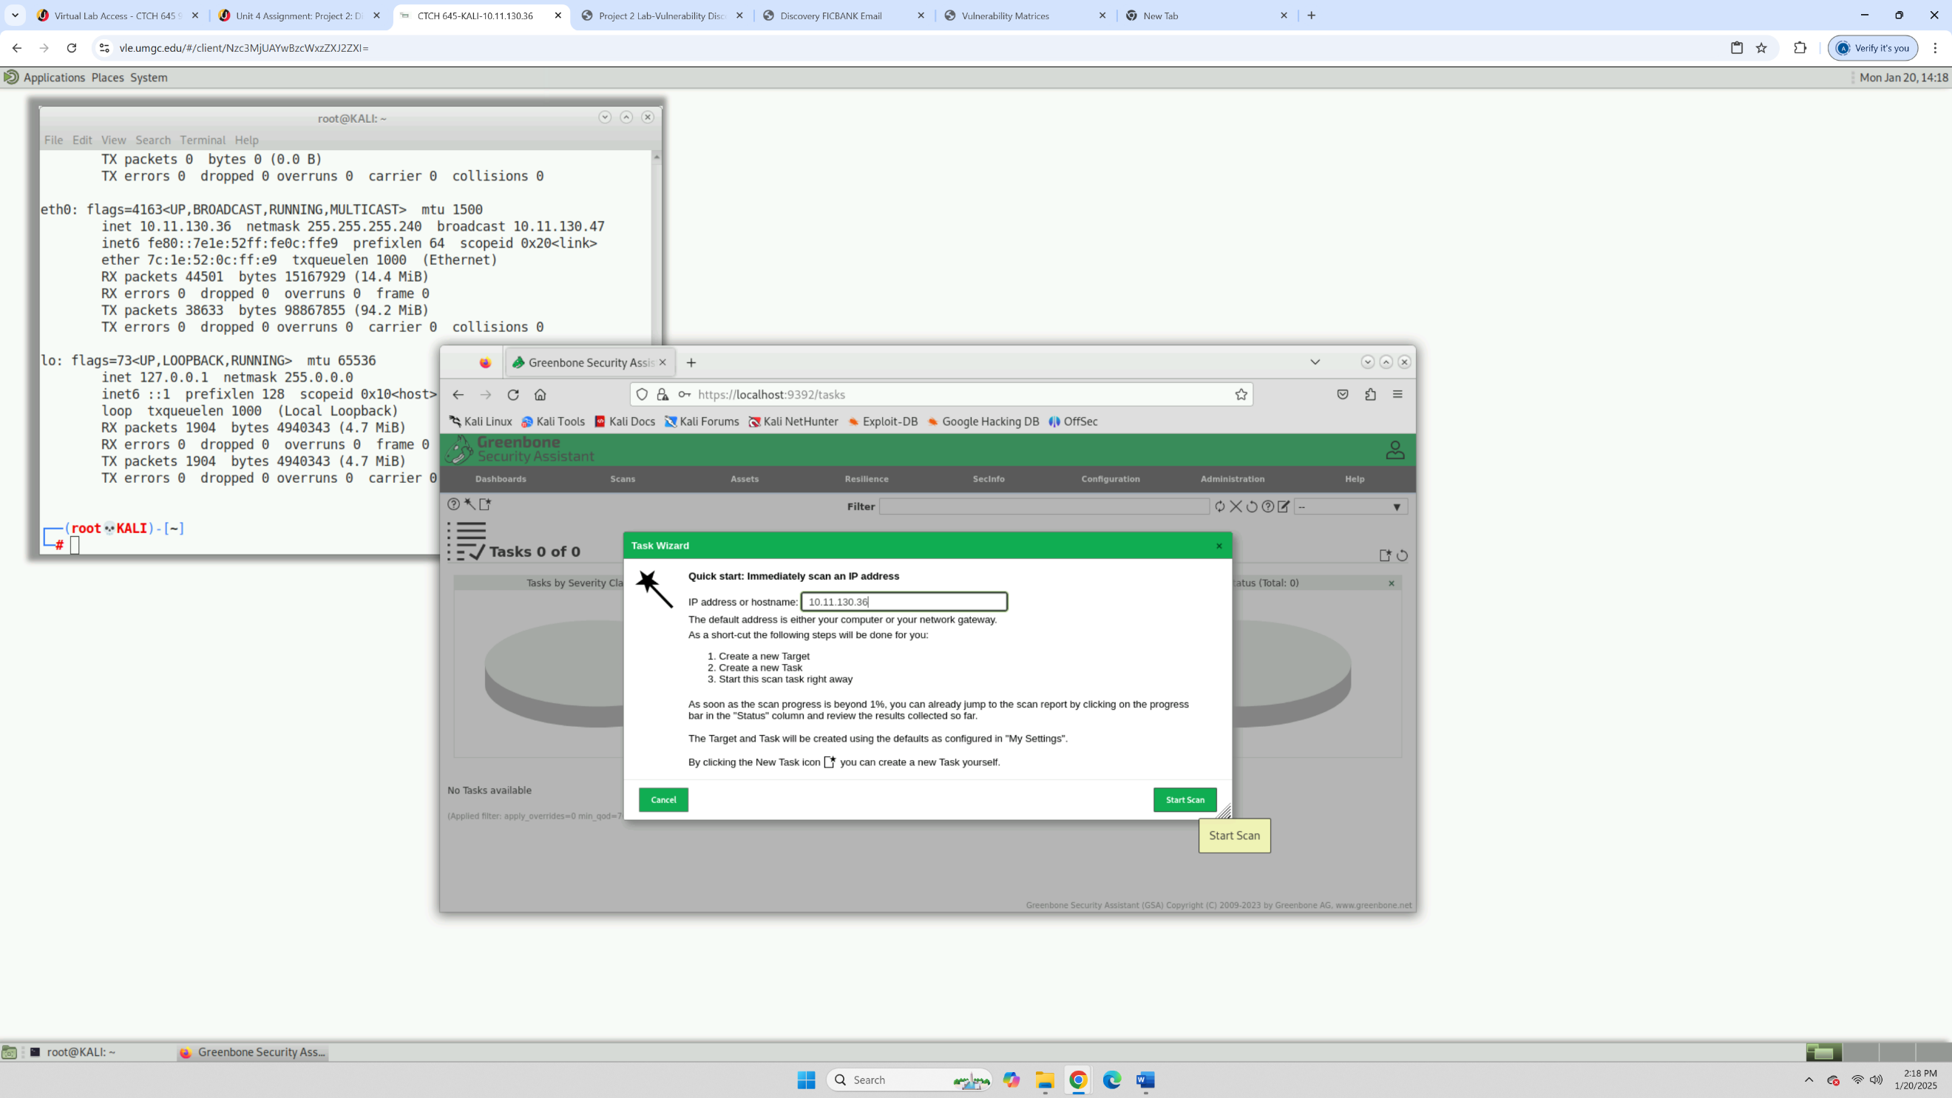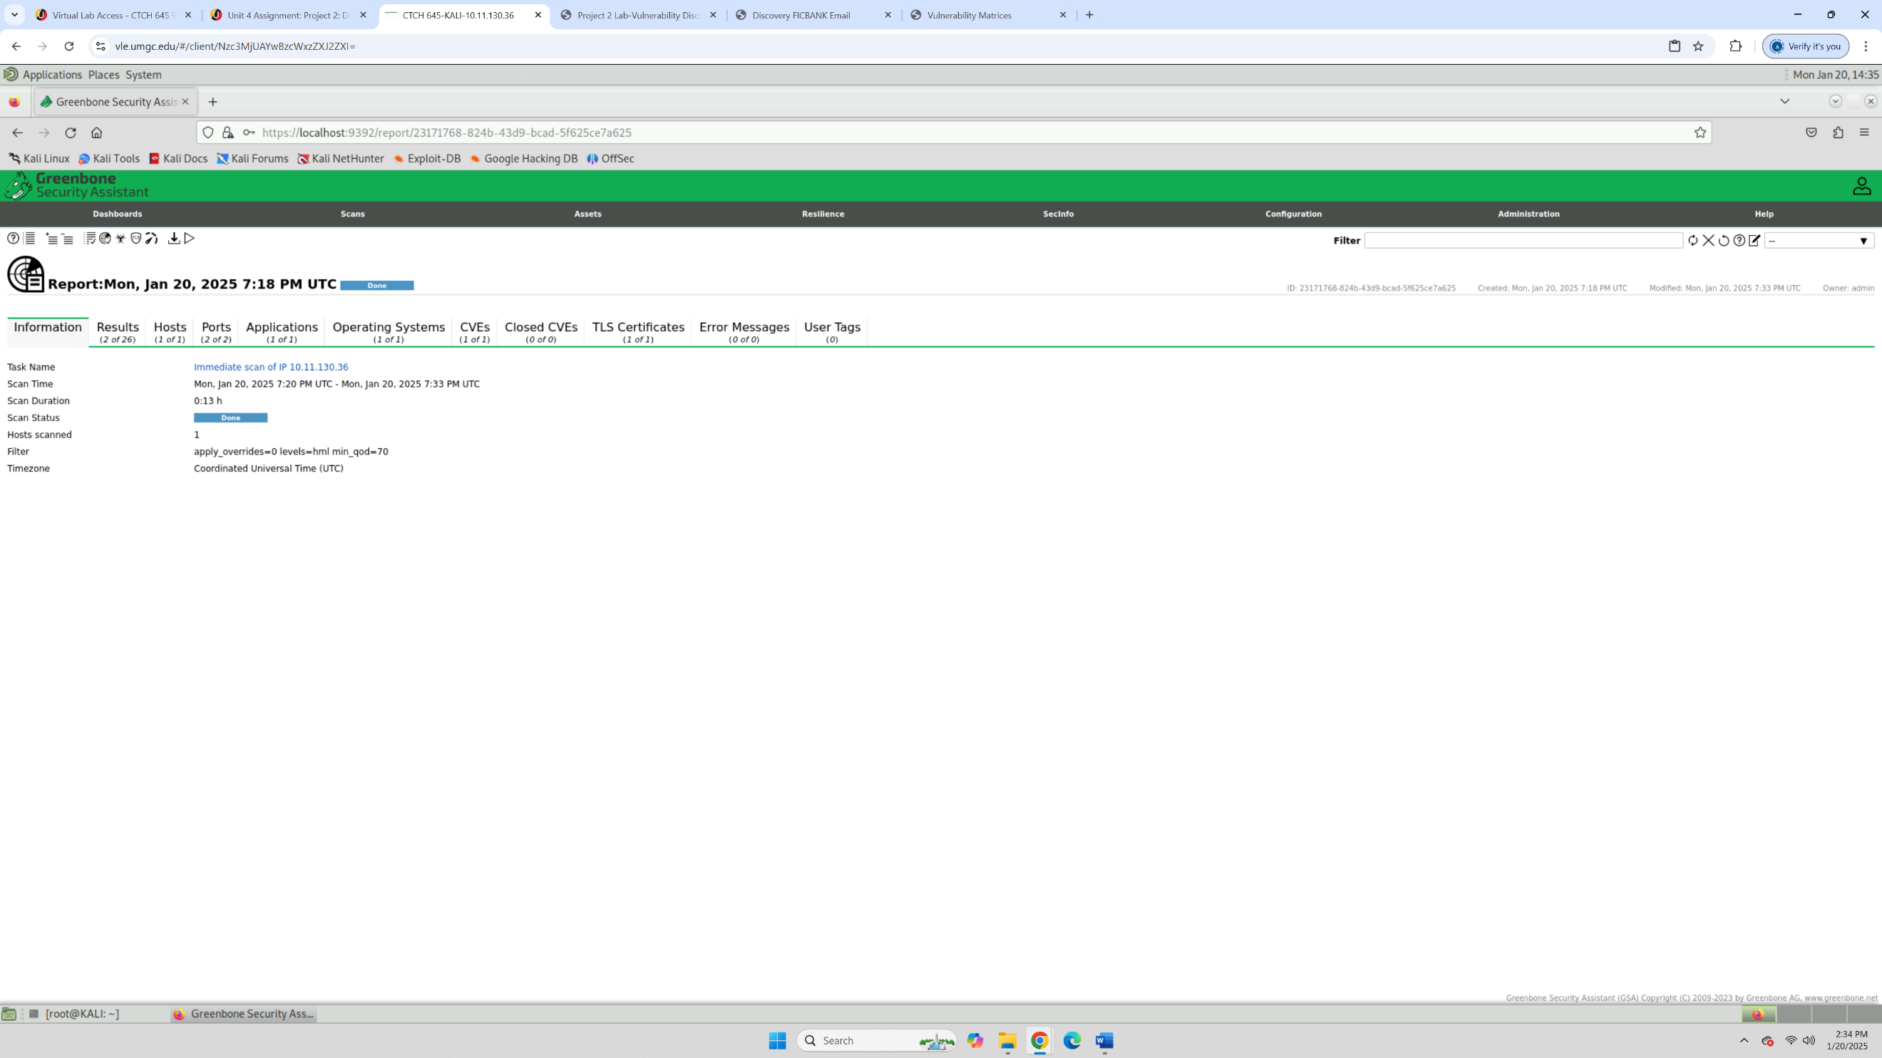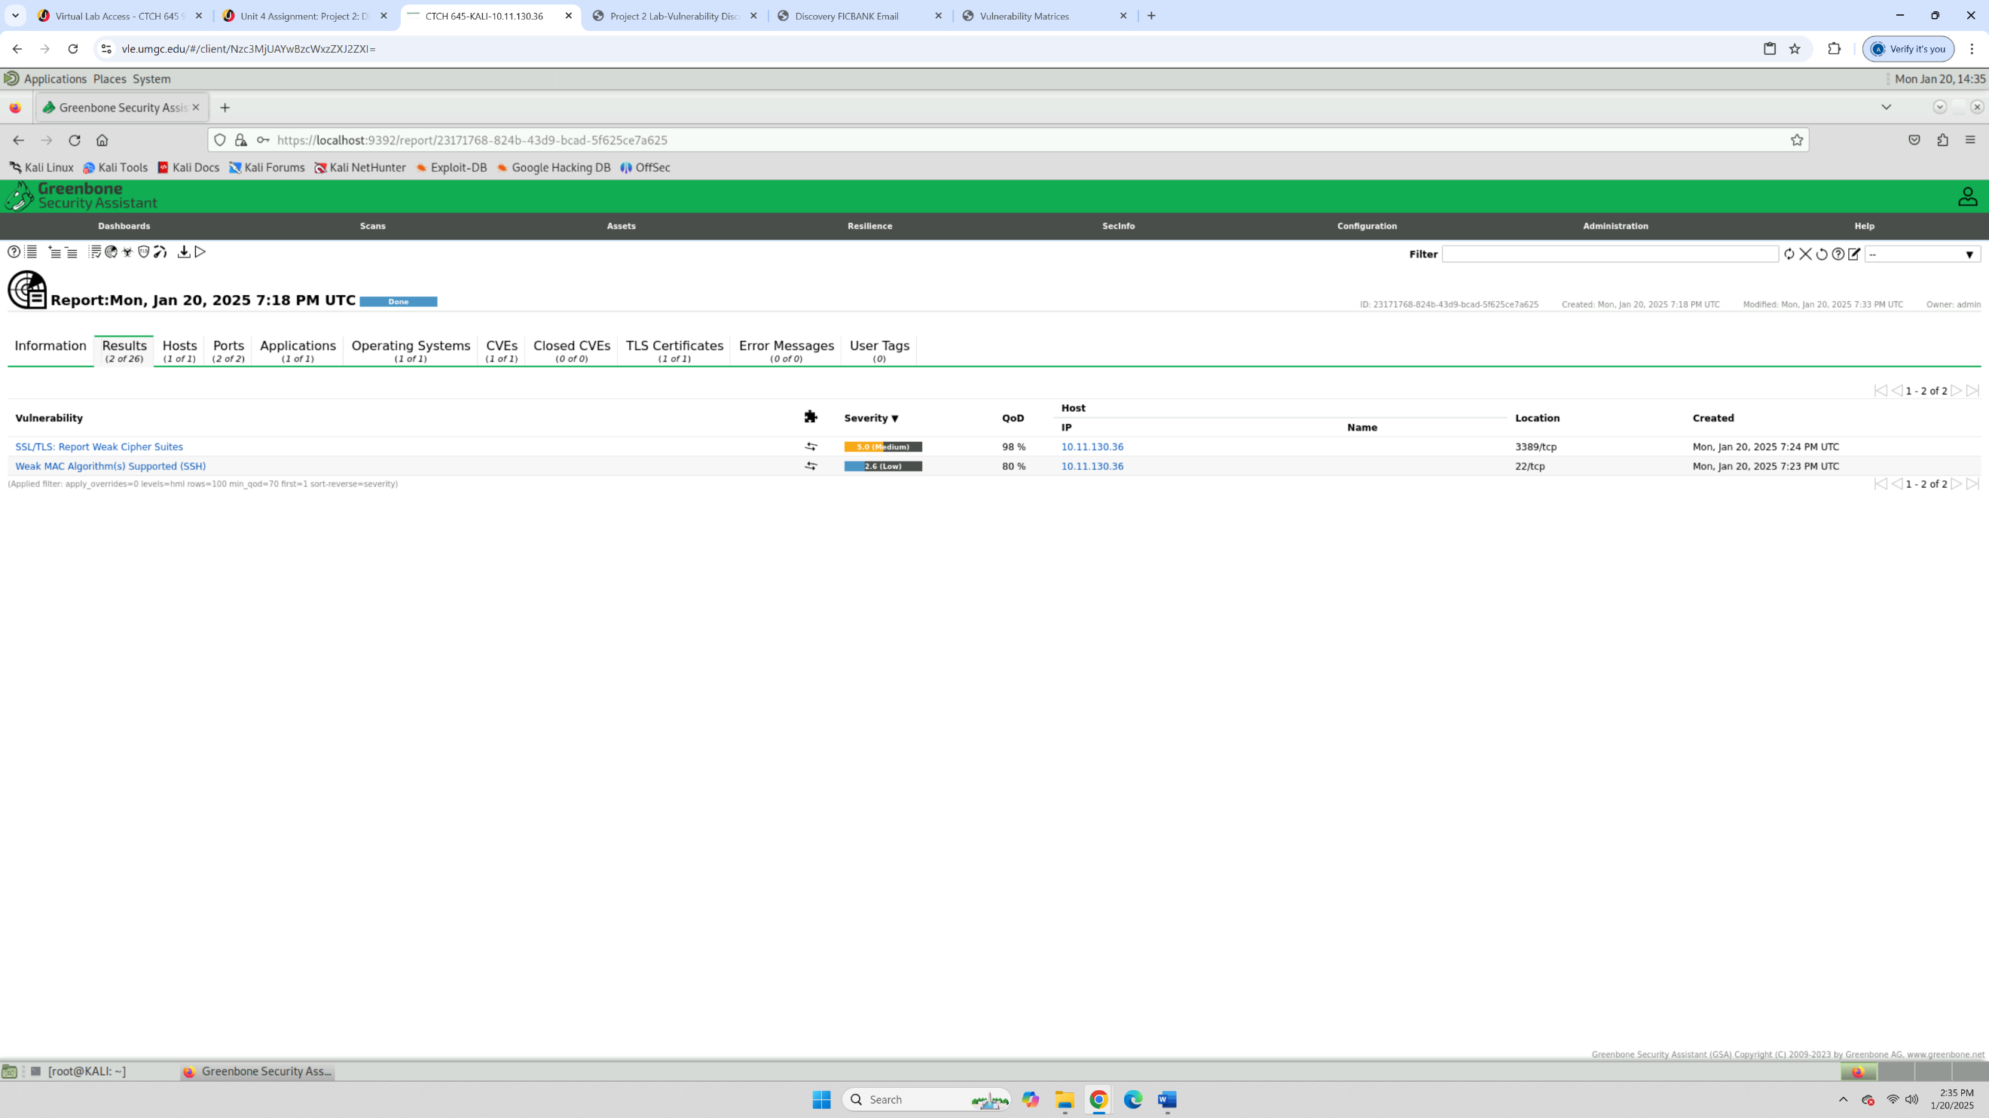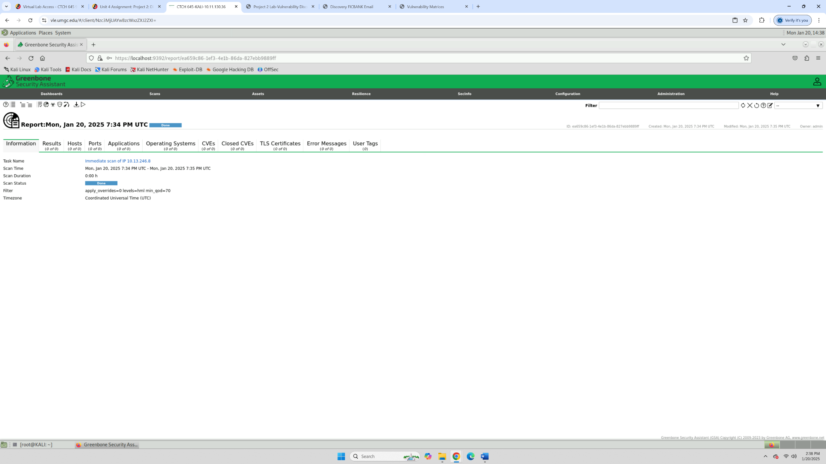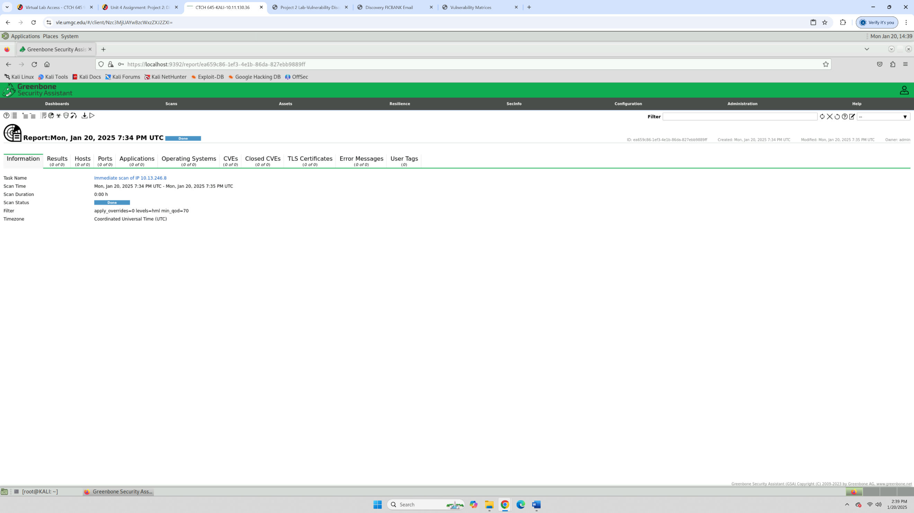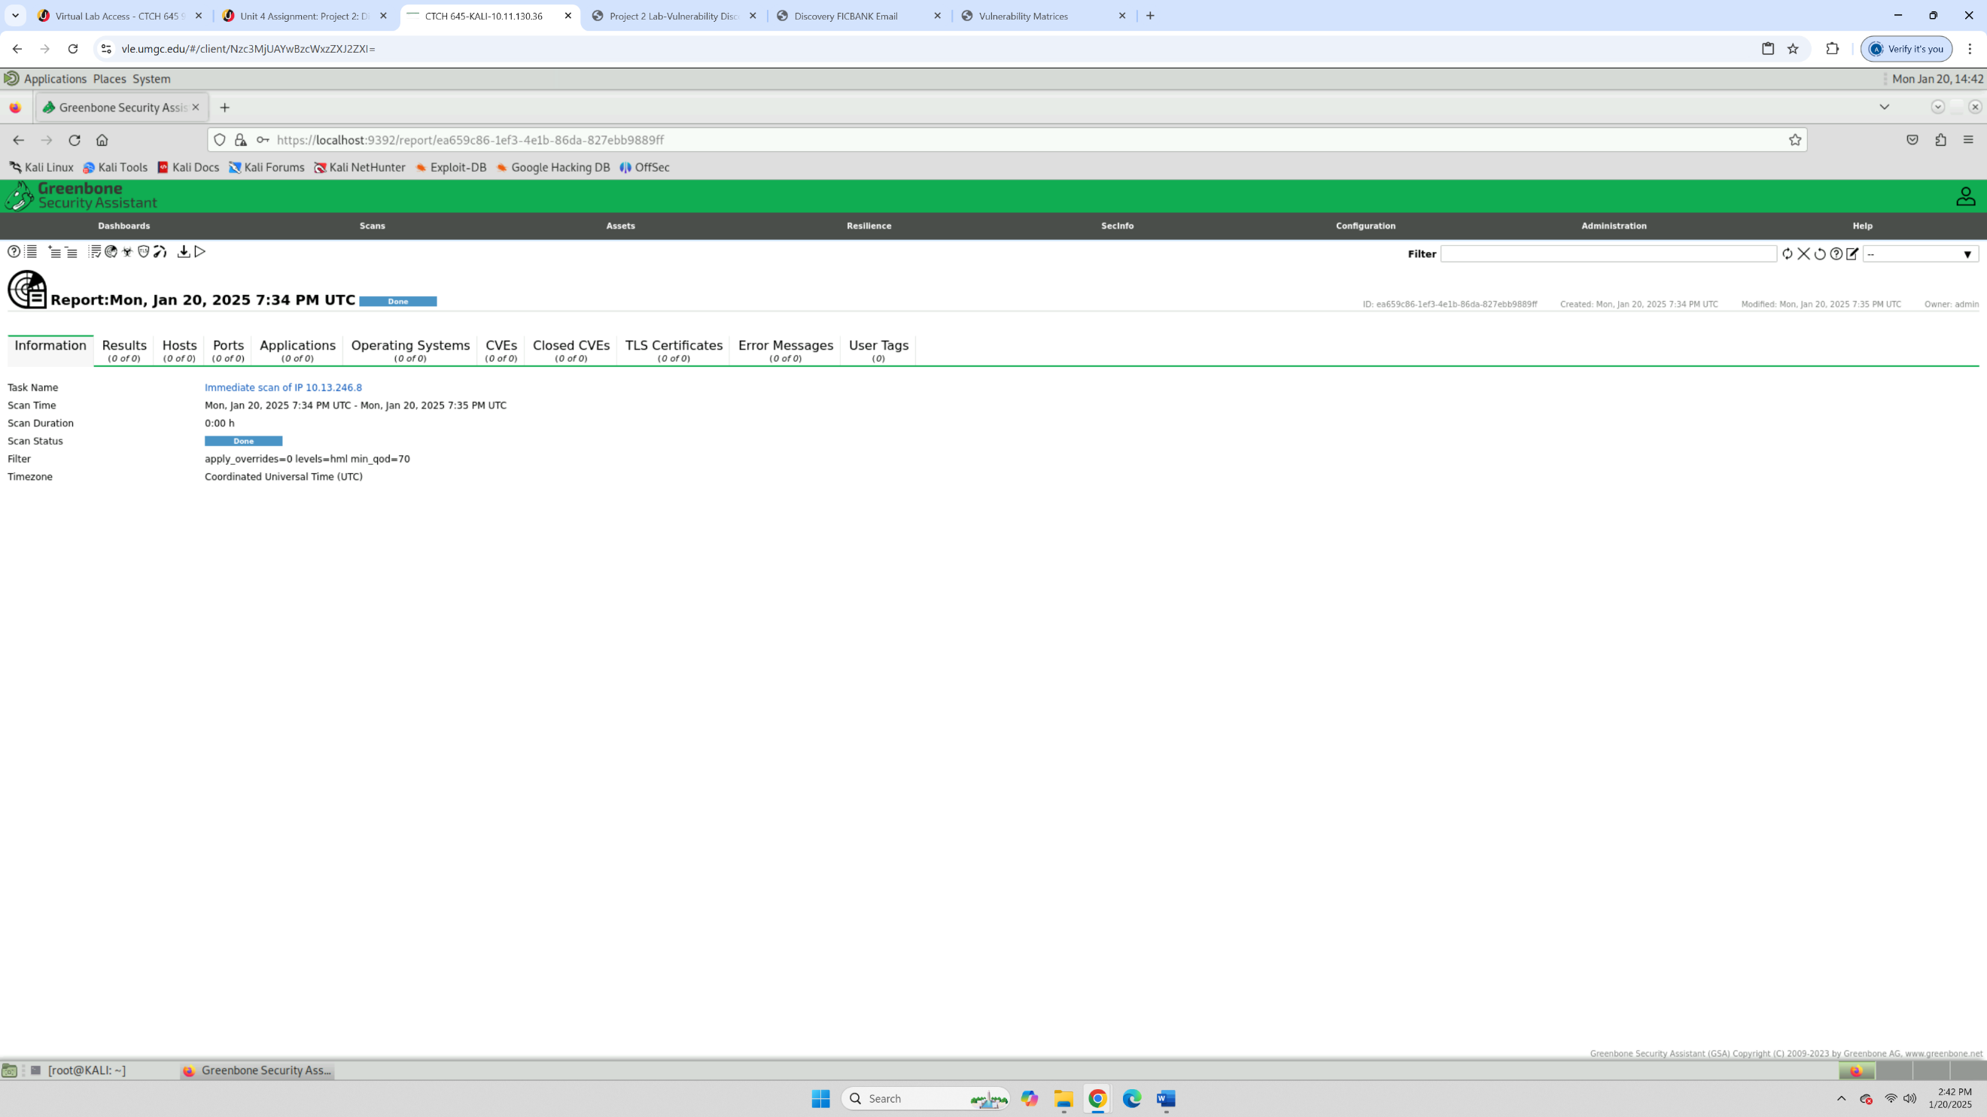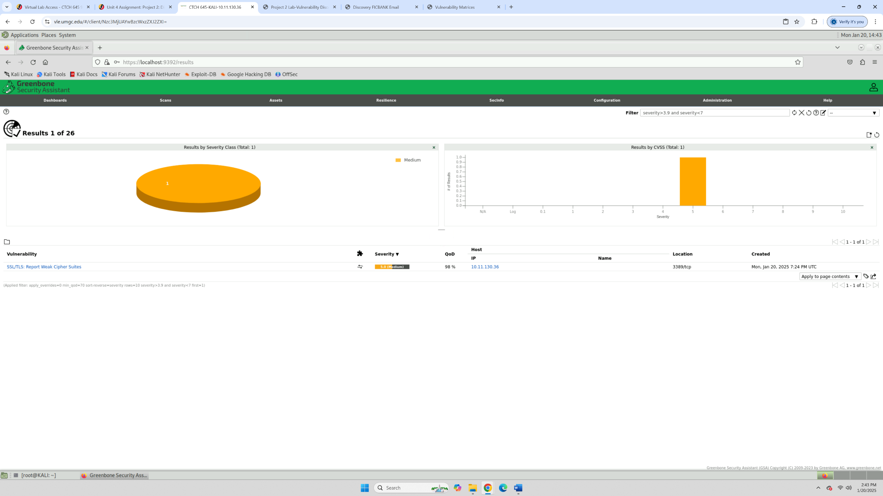
1. What can you say about the impact of these vulnerabilities from the different scans and how do they relate to risk assessment?
The vulnerabilities detected, such as weak encryption and missing security headers, pose significant risks to data confidentiality and integrity. In risk assessment, these vulnerabilities are analyzed based on their potential impact and likelihood, influencing security measures and mitigation priorities.
2. Is vulnerability scanning invasive or noninvasive?
Vulnerability scanning is considered invasive because it actively probes systems to detect weaknesses by sending packets and analyzing responses. However, it does not exploit vulnerabilities, making it less intrusive than penetration testing.
3. What do you notice about the severity levels and scan duration of the scans produced between the Kali Linux and the Windows Desktop VMs? Did the scan take a longer or shorter time, and what does that tell you about remotely scanning a target?
The Kali Linux scan completed relatively quickly with a few medium-risk vulnerabilities, while scans on Windows desktops tend to take longer due to a larger attack surface and more services running. This indicates that scanning complexity depends on the number of open ports, services, and security configurations.
4. Were there any identified open ports, known exploits, unauthorized file access, or web vulnerabilities such as cross-site scripting or SQL injection? How did you use the OpenVAS tool to determine those vulnerabilities?
The scan identified open ports (80, 443, 22) but did not detect critical web vulnerabilities like SQL injection or XSS. OpenVAS was used to perform in-depth scanning and vulnerability identification by leveraging its extensive CVE database and reporting capabilities.
5. What can you say about the solution provided and what can happen if it is not implemented?
The recommended solutions, such as updating encryption protocols and closing unnecessary ports, are essential to prevent attacks like data breaches and unauthorized access. Failure to implement them could leave the systems vulnerable to exploitation by attackers.

Appendix C – Exploitation Phase
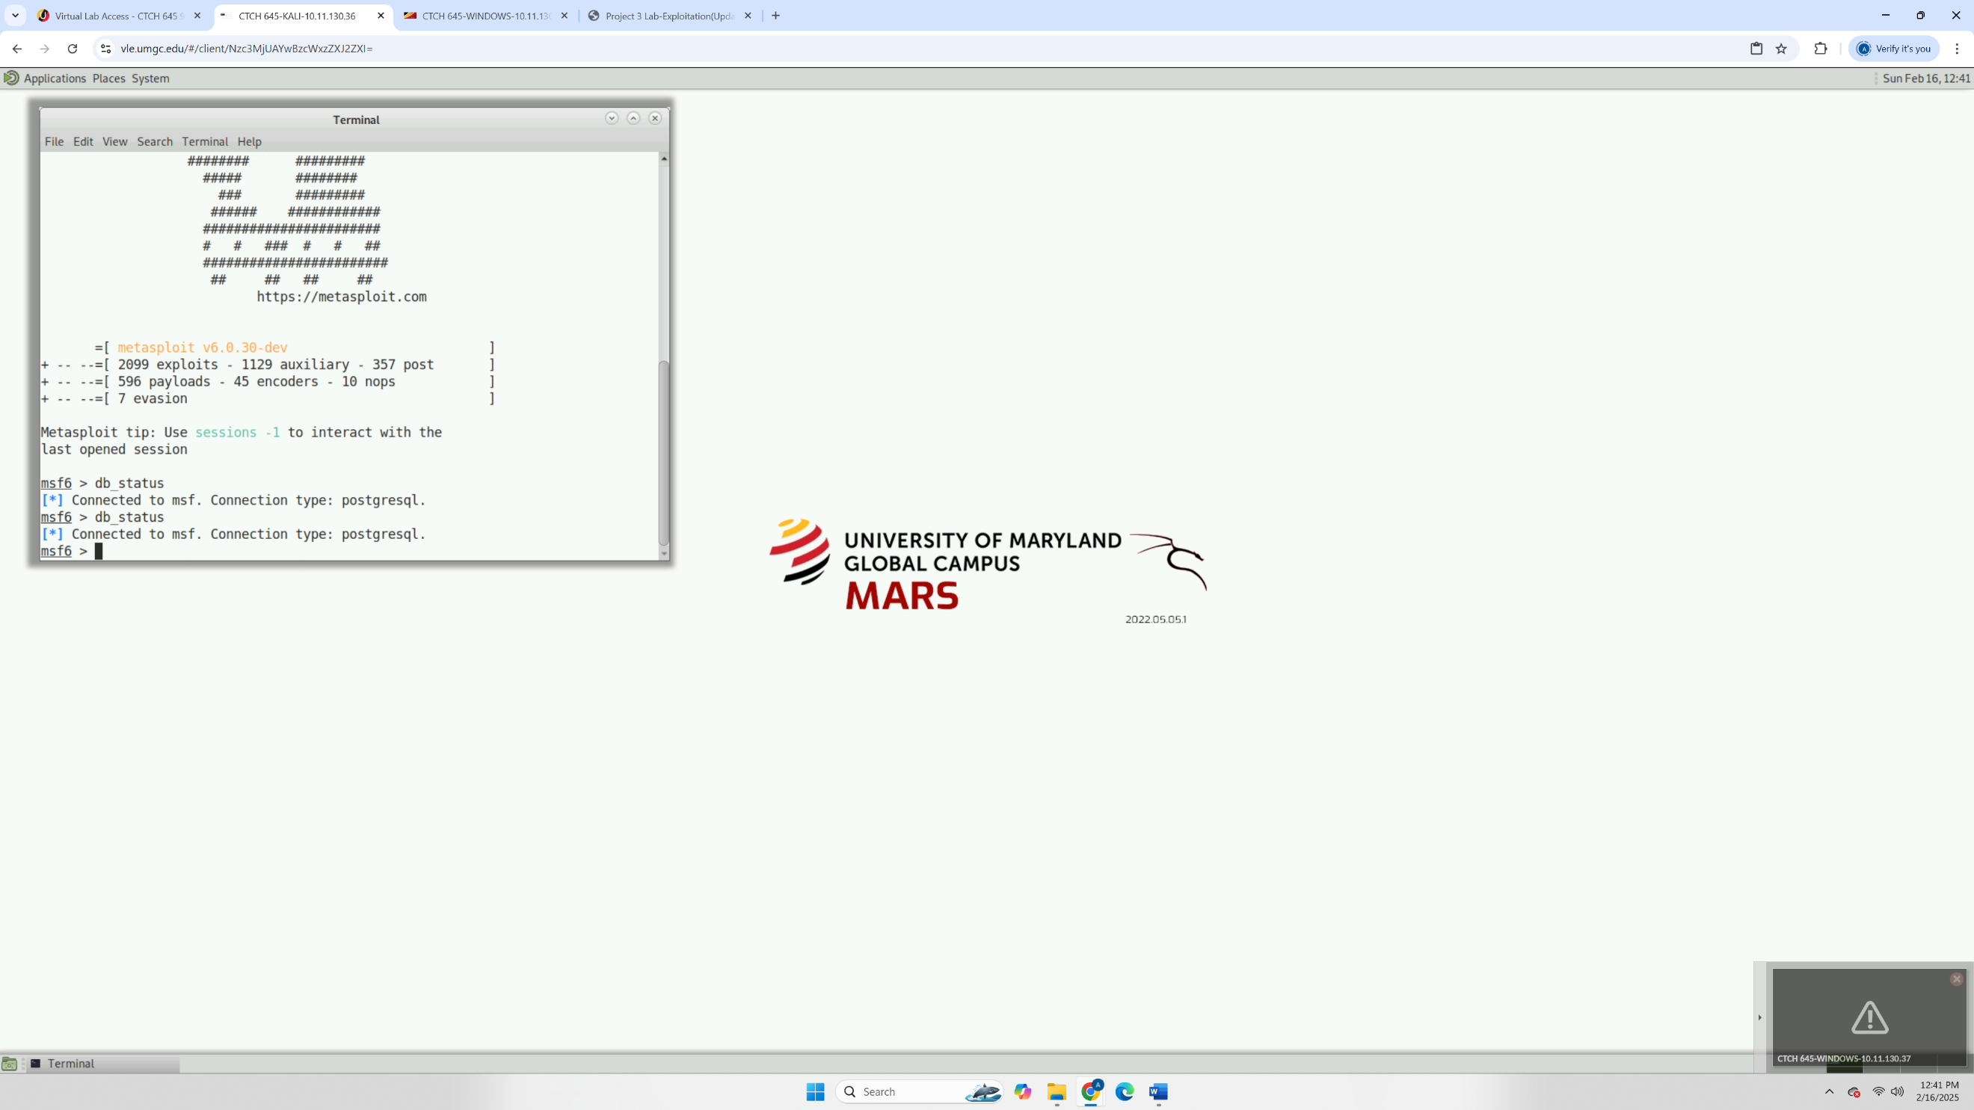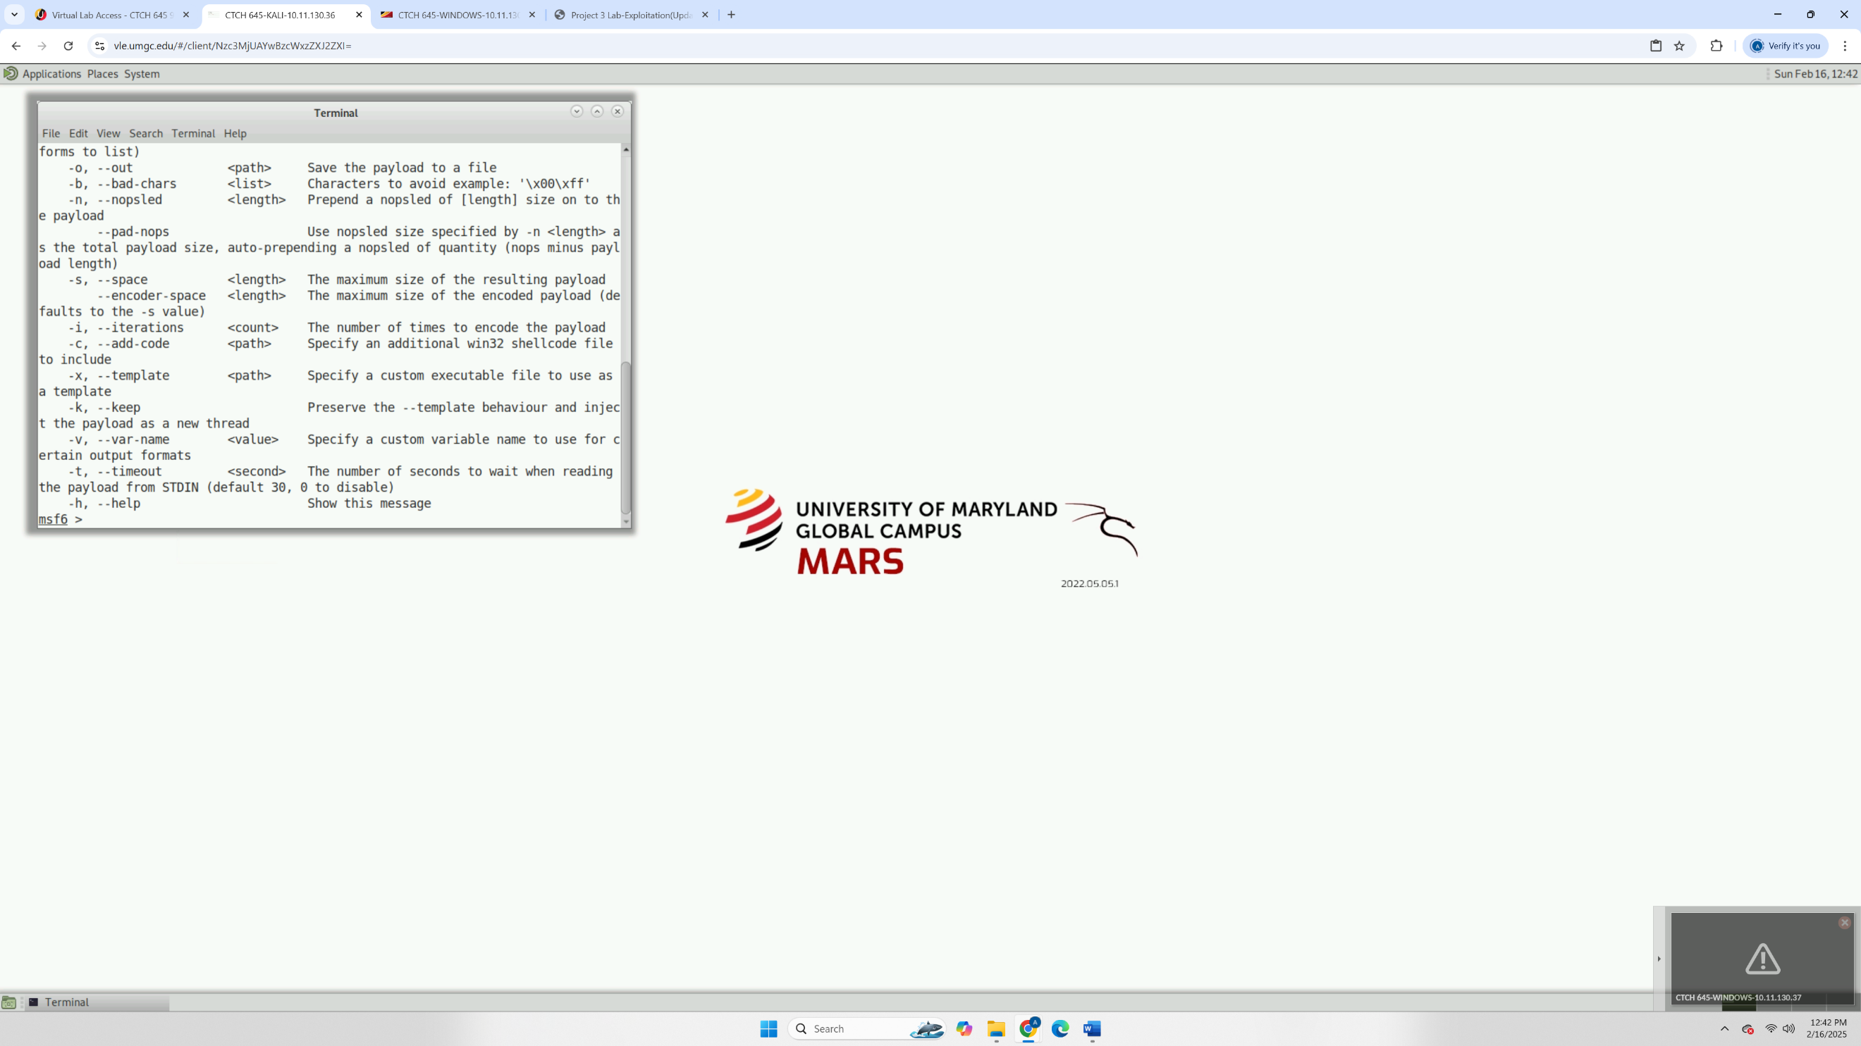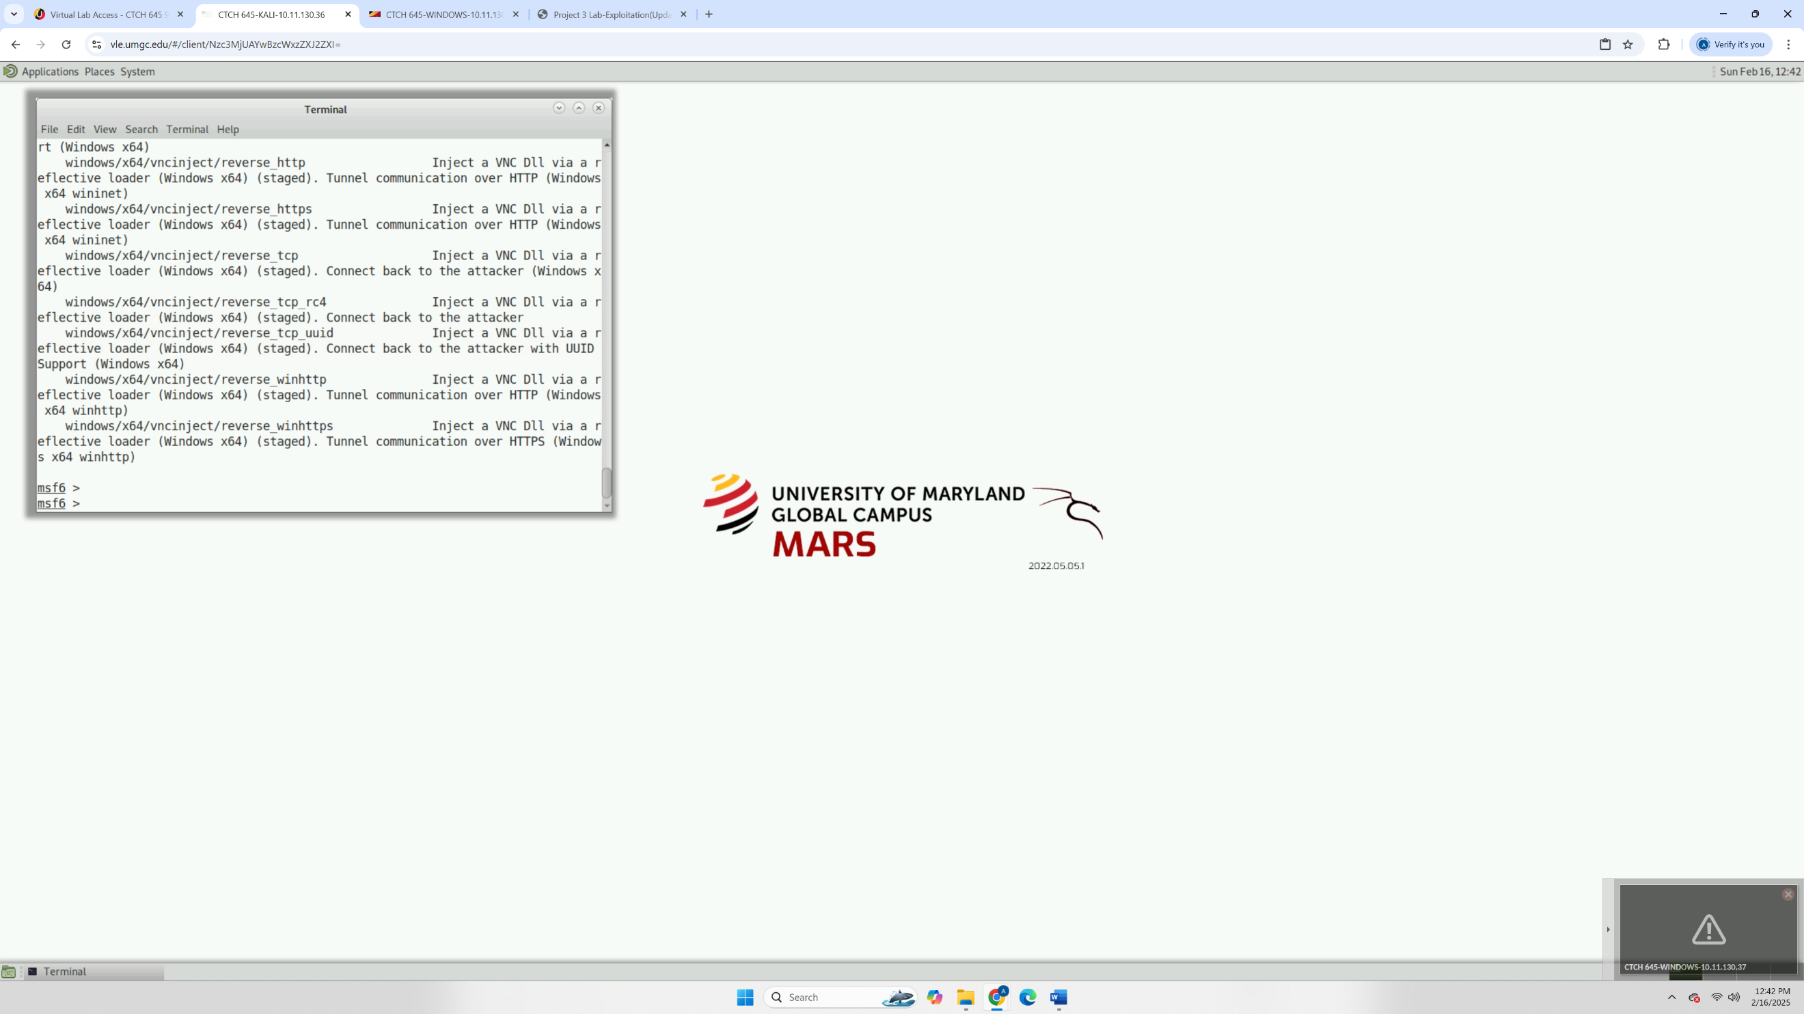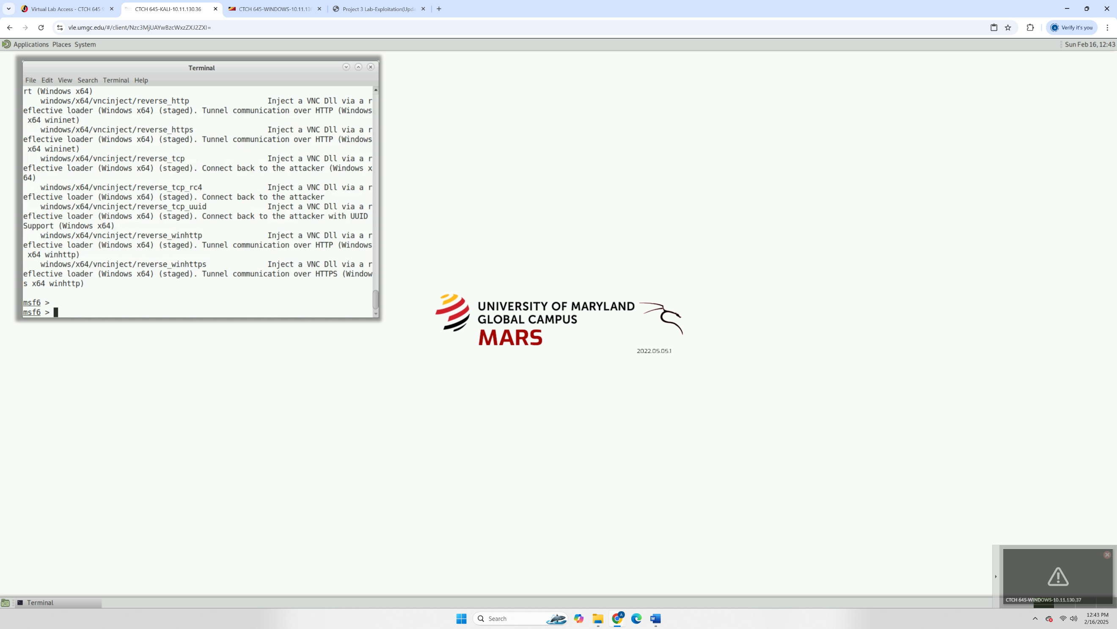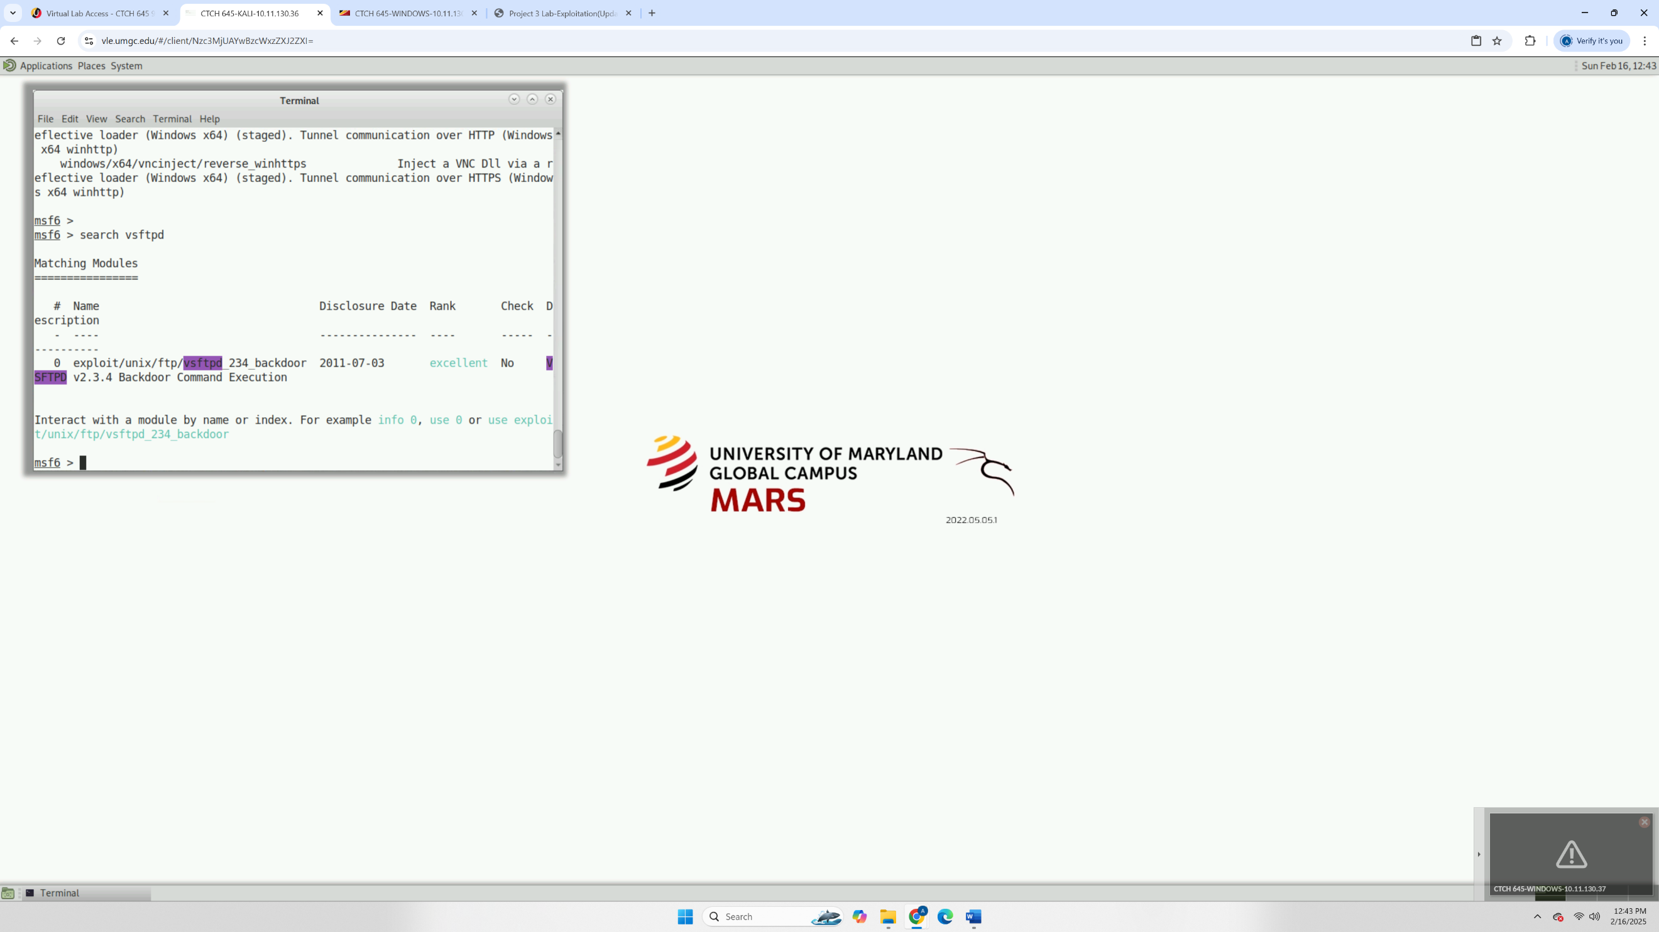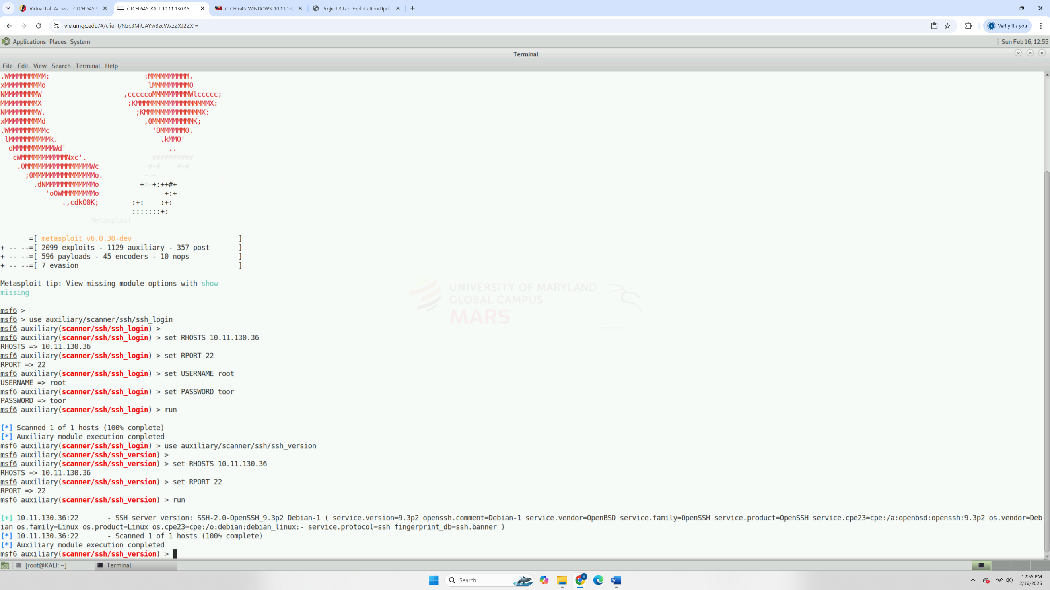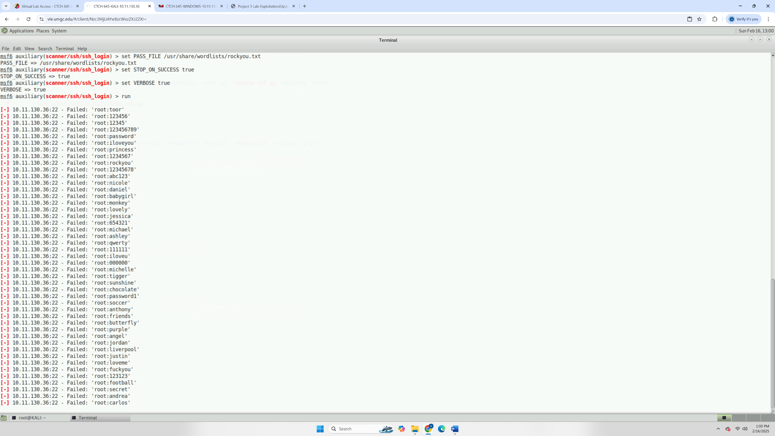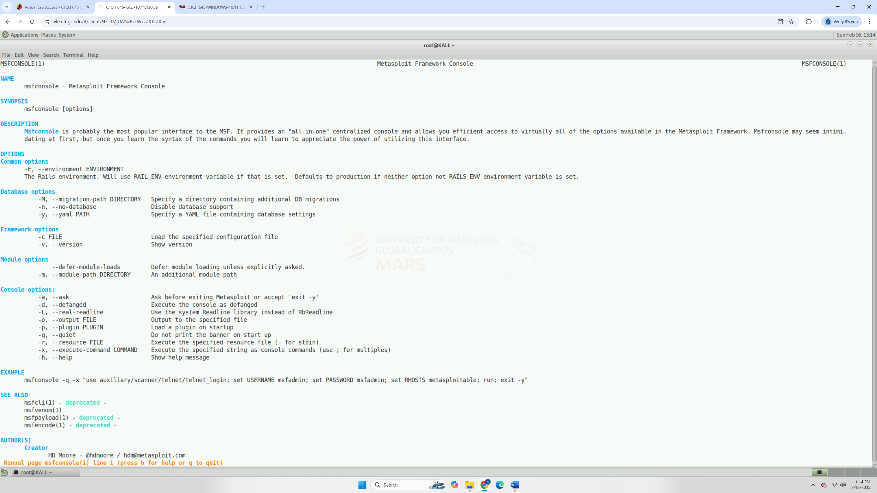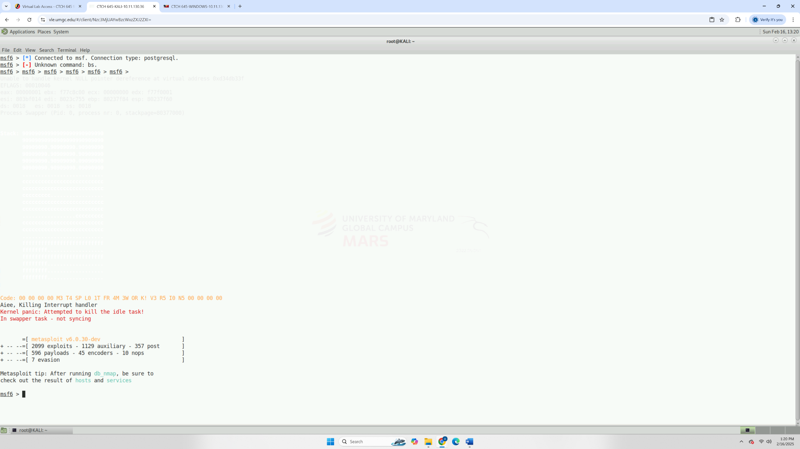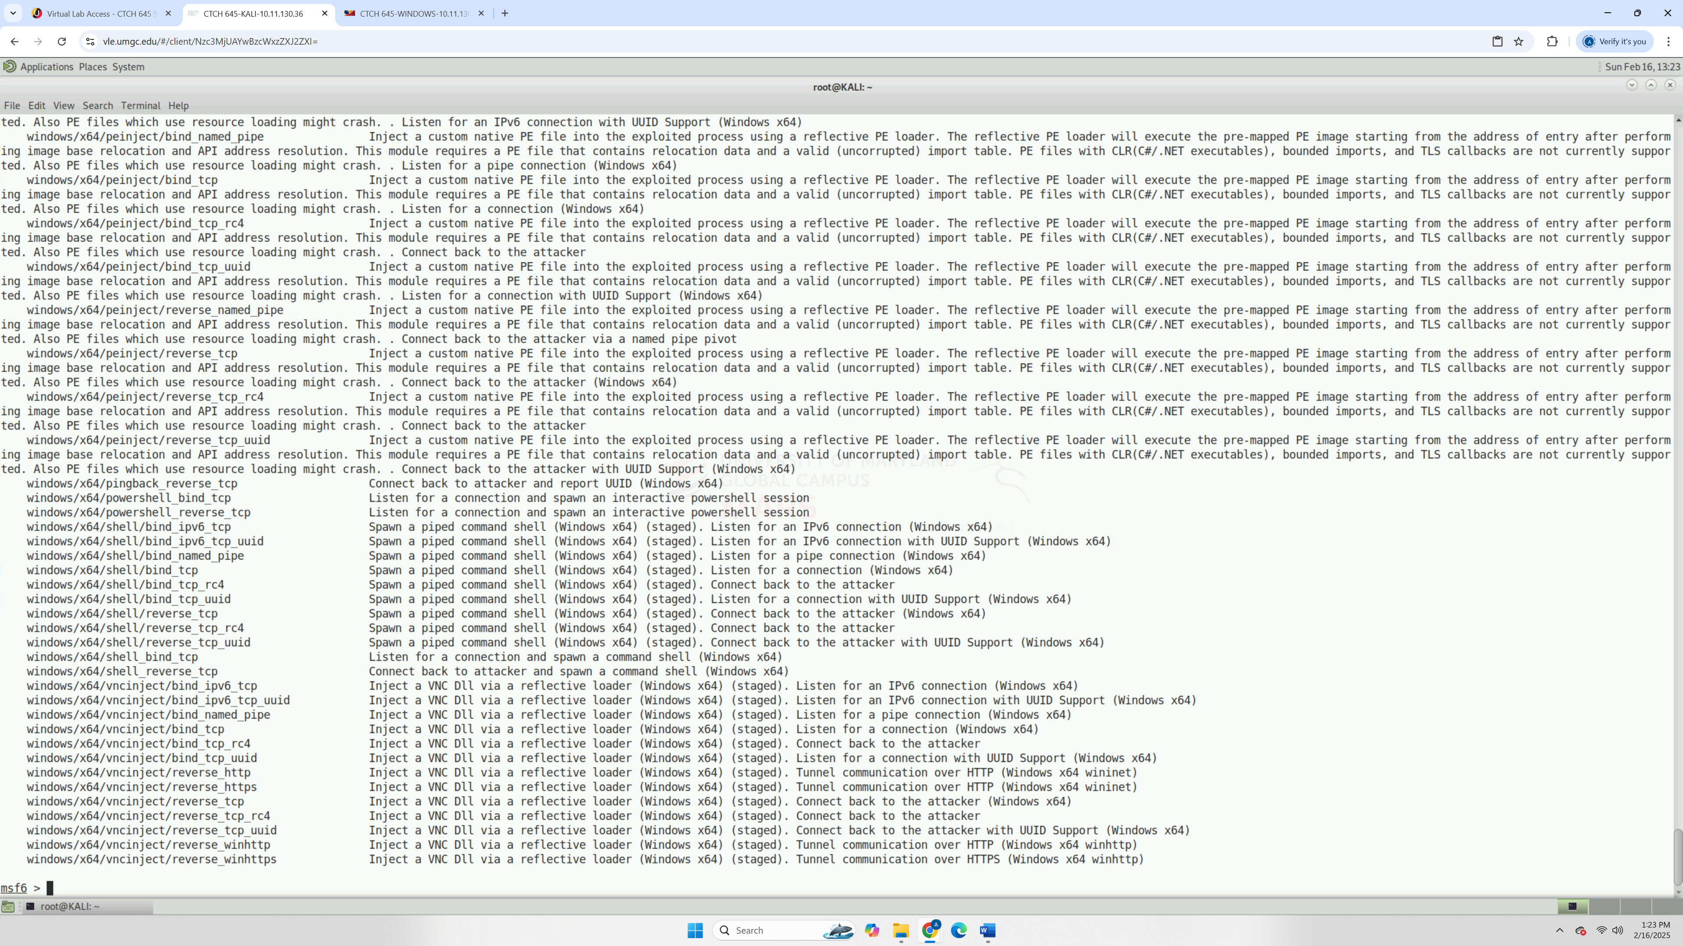
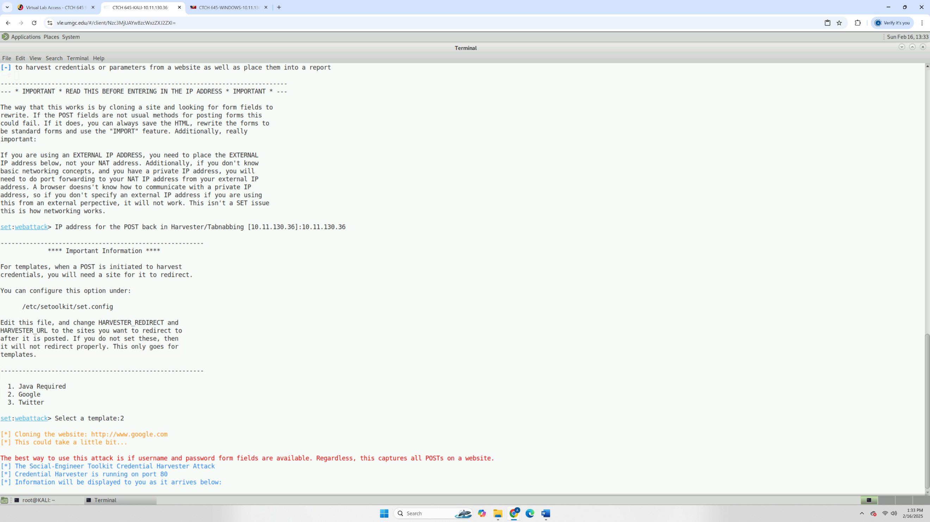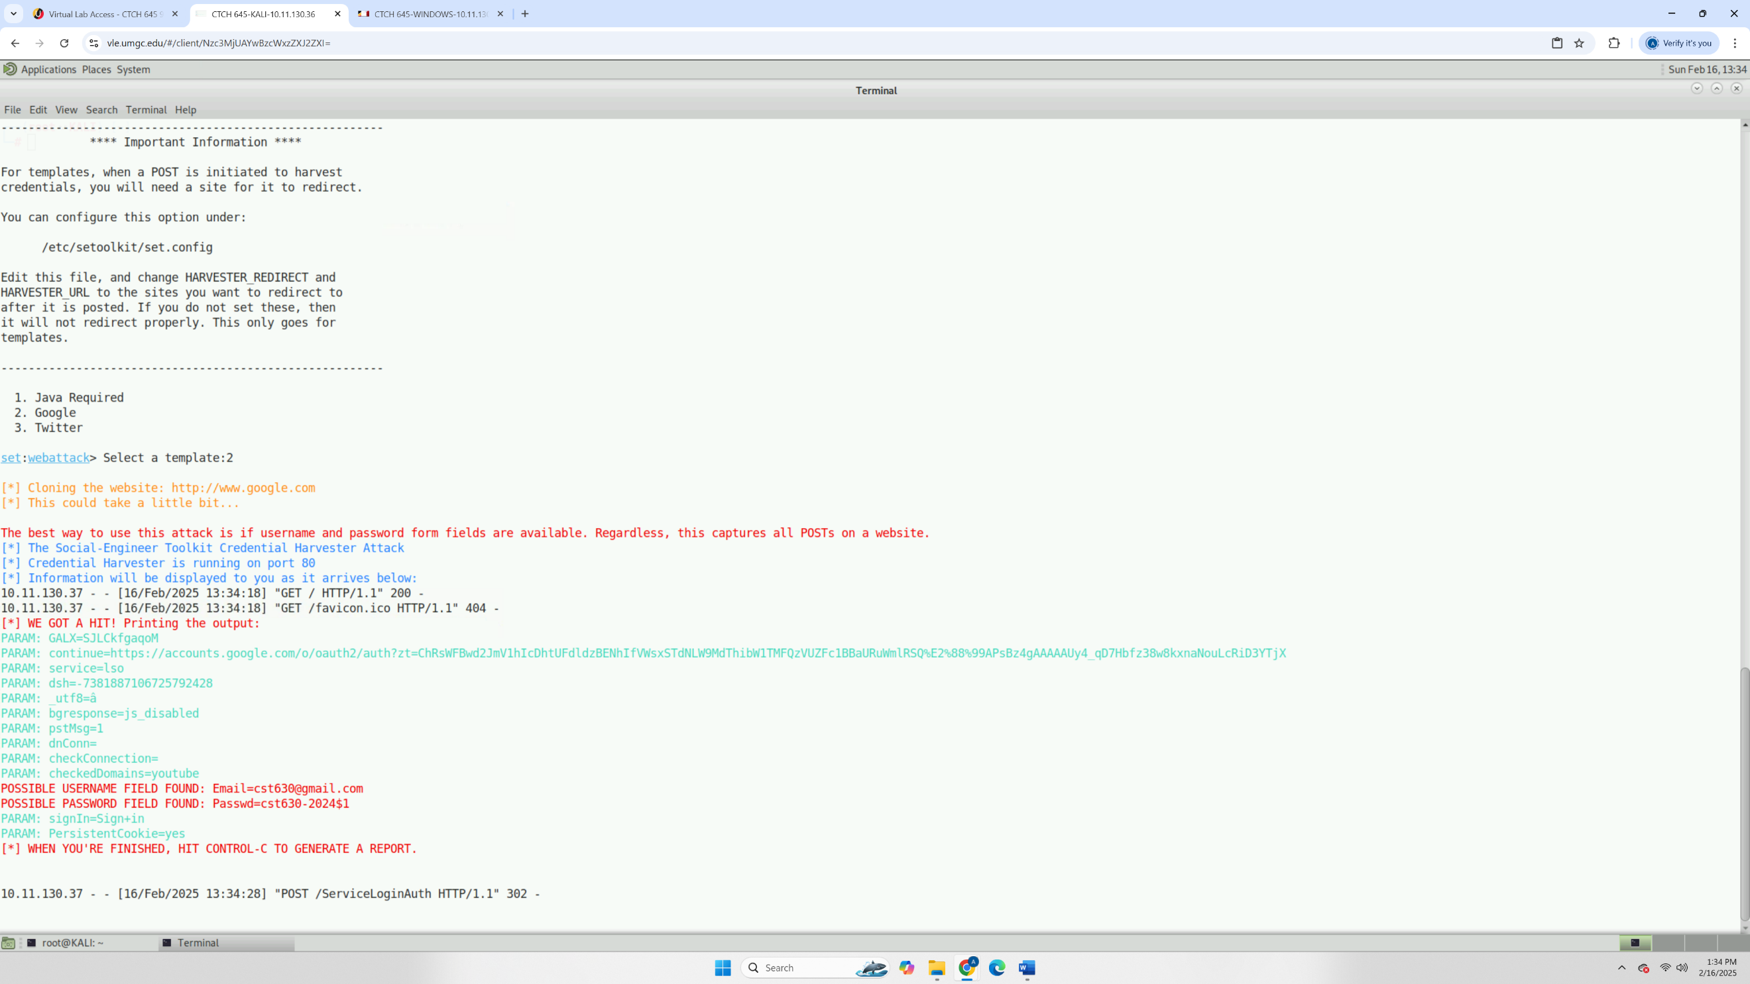
Based on your pen testing experience gained in this lab, what can you do to ensure that your client organization incorporates pen testing as part of its implementation procedures or security awareness program to ensure optimum internal or external security? To ensure penetration testing becomes a core part of an organization's security strategy, it should be conducted regularly, quarterly or biannually, to stay ahead of evolving threats. It should also be integrated into security policies and compliance frameworks like NIST or ISO 27001, ensuring leadership prioritizes it. Beyond just identifying vulnerabilities, organizations should take actionable steps to fix them, such as patching software, enforcing multi-factor authentication (MFA), and improving employee security awareness through phishing simulations. Ultimately, penetration testing should not be a one-time event but an ongoing effort to strengthen defenses, educate employees, and proactively address security risks.
Assuming you are a member of a pen testing team, and you identify vulnerabilities and exploits in your client’s network, should you obtain written permission prior to compromising the known vulnerability? Why or why not in terms of rules of engagement? Yes, written permission is absolutely necessary before exploiting a known vulnerability. In penetration testing, the rules of engagement must be clearly defined to ensure all actions are legal, ethical, and within the agreed scope. Without explicit authorization, attempting to exploit a system, even for testing purposes, could be considered unauthorized access, which is illegal under laws like the Computer Fraud and Abuse Act (CFAA). A signed agreement protects both the testing team and the client by outlining what systems can be tested, what methods are allowed, and what steps will be taken to mitigate risks. It also ensures that testing does not accidentally disrupt critical operations.
As a cybersecurity consultant, you were part of a team hired to conduct pen testing to evaluate the security of your client’s IT infrastructure. Why is it critical to perform pen testing on the internal network of your client prior to production implementation? Performing penetration testing on the internal network before production implementation is crucial because it helps identify and fix vulnerabilities before they can be exploited by real attackers. Internal threats, misconfigurations, or weak security controls can go unnoticed until a system is live, making it a prime target for attacks. By testing early, security teams can proactively strengthen defenses, prevent costly breaches, and ensure compliance with security standards. It also reduces downtime by addressing issues in a controlled environment rather than dealing with security incidents after deployment.
Assuming you received an email from your boss asking you to urgently click a link in the email or asking for your sensitive data such as credit card information. What will you do as a matter of urgency needing immediate response? Describe your approach. If I received an urgent email from my boss asking me to click a link or provide sensitive information, I would stay calm and verify its legitimacy first. I’d check for red flags like unusual language, unexpected requests, or a suspicious sender address. Instead of clicking the link, I’d hover over it to inspect the actual URL. If still in doubt, I’d contact my boss directly through a verified phone number or an internal communication channel to confirm the request. If it turns out to be phishing, I’d report it to the security team immediately to prevent potential harm to the organization.

Appendix D – Post-Exploitation Cleanup Phase
Based on your pen testing experience gained in this lab, what can you do to ensure that your client organization incorporates pen testing as part of its implementation and mitigation procedures to ensure optimum internal or external security? To ensure that the client organization incorporates penetration testing as part of its implementation and mitigation procedures, I would recommend establishing a structured and ongoing penetration testing program. This includes conducting regular scheduled tests, incorporating penetration testing into the software development lifecycle, and using the findings to improve security controls. Additionally, employee security awareness training should be reinforced based on test findings to mitigate risks from social engineering attacks. Finally, clear documentation and reporting of vulnerabilities, along with remediation plans, will help integrate pen testing into the organization’s security framework, ensuring both internal and external security are continuously evaluated and improved.
As a cybersecurity consultant, you were part of a team hired to conduct pen testing to evaluate the security of your client’s IT infrastructure. Why is it critical to perform pen testing on the internal network of your client prior to production implementation? Performing penetration testing on the internal network before production implementation is critical because it helps identify and address security vulnerabilities that could be exploited by malicious actors once the system is live. Internal testing allows the organization to evaluate how well security controls protect sensitive data, detect misconfigurations, and uncover potential insider threats. It also helps ensure compliance with industry standards and regulatory requirements. By identifying and mitigating security risks early, the organization can prevent costly breaches, minimize downtime, and strengthen its overall security posture before exposing the network to real-world threats.
Based on the successful attacks you executed—for example, exposing user credentials with the Credential Harvester—what kinds of cleanup activities would be necessary?
After executing successful attacks, such as exposing user credentials to the Credential Harvester, several cleanup activities are necessary to remove any residual traces and ensure the integrity of the system. These include:
- Clearing Logs – Remove any logs from the penetration test that could expose details about the testing process, including access attempts, payload executions, or credential harvesting. This helps maintain operational security and prevents unauthorized access to sensitive information.
- Disabling Backdoors and Access Points – If any backdoors, shells, or persistent access mechanisms were created during testing, they should be removed to prevent unauthorized use after the test.
- Restoring System Configurations – Reset any system settings, network configurations, or security controls that were altered during testing to their original state. This ensures normal operation and prevents unintended security risks.
- Changing Exposed Credentials – Any credentials captured during the test, such as usernames and passwords, should be reset to prevent unauthorized access by malicious actors who might have observed the attack.
- Verifying Security Controls – Conduct a final security check to confirm that all security measures are still functioning as intended and that no vulnerabilities were left open after testing.
- Documenting Findings and Reporting – Provide a detailed report of the test results, including the vulnerabilities exploited, the impact of the attacks, and recommendations for strengthening security. This documentation is crucial for improving the organization’s security posture.
These steps ensure that the testing process does not leave the system vulnerable, and that the organization can use the findings to enhance its cybersecurity defenses.
Penetration tests are invasive. Recommend two or three steps prior to exploitation you might recommend be done to ensure proper disaster recovery should a target be taken offline by an exploit.
Before conducting penetration testing, it’s crucial to take steps to ensure proper disaster recovery in case a target system is taken offline. Here are three key steps to follow:
- Create Full System Backups – Before any exploitation begins, perform a complete backup of all critical systems, including databases, configurations, and network infrastructure. This ensures that any unintended disruptions can be quickly restored to their original state.
- Establish a Rollback Plan – Implement a detailed rollback procedure that outlines the steps to restore affected systems if they go offline. This includes having recovery scripts, virtual machine snapshots, or redundant failover systems ready to deploy.
- Define a Communication and Incident Response Plan – Ensure that all relevant stakeholders, including IT administrators and security teams, are aware of the test and have a clear plan to respond if an outage occurs. This includes setting up monitoring tools to detect disruptions in real time and having a point of contact available for immediate troubleshooting.
Taking these precautions helps minimize risk during penetration testing and ensures that systems can be quickly restored in case of unexpected failures.

